🗺️ Project Outline & Planner

# Project Outline & Planner

Check OUT 7/11

Progress your group made on To-Do items discussed in stand up

* Watched videos about coherence scoring, topic modeling, and LDA
* Uriel completed some more of the missing visualizations
* Had a discussion about the models output and how we will actually saved the topics per document

Challenges you faced today and how you overcame them or are still struggling

* Faced some disorganizationRemaining To-Do's you will keep working on going forward
* in our visualization slides, but are fixing them
* N-grams next week
* Naming topics for models
* Choosing which models to keep and get rid of
* Optimizing those models going forward

Check OUT 7/17

Progress:

* We fixed the bugs in pLSA and LDA (raw) models, so now all models from ‘round 1’ are complete
* From there we continued “topicing” topic outputs an have 3 left

Challenges:

* pLSA gave us LOTS of issues to run, but we will still be evaluating its output

TO-DO:

* pLSA n-grams
* Finish ‘topicing’ pLSA, pLSA n-grams, LLMBERTopic FuzzyCmeans, and LLMBERTopic FuzzyCmeans n-grams
* Solidify topic choices for ‘round 2’
* Remove duplicates!!
* Do tweaks such as date removal, company name removal, and mess around with stemming and lemmnization
* Remember lightning talks are coming up
  + Make model comparison visualization
  + Plan story telling

Check OUT 7/25

Progress:

* Yuliia= Distil bert accuracy is at 85%, everyone else is adapting yuliias code form this model, to teh others
* Kamare= spanbert
* Uriel= twitter
* Hellena= electra
* Above four people also did some documentation on where teh bert topic model left off and teh optimizations attempted
* Theron is finishing the abstract
* Nicole is working on some methods documentation, the lightning talk 8/1 slides, final slides, and project poster

Challenges:

* No specific challenges, still waiting on test data

TO-DO:

* Implement Yulias code to all other models
* Work on deliverables
* Updates to github

⚡ Lightning Talk

Intro: Theron (3 min)

Can we mention the RSPO here and the grievance logs?

Palm oil industry and the issues that there going on

Problem Statement: Kamare (1 min)

* Problem: Complaints about the harms caused by the palm oil industry are scattered across many different data sources and consist of unstructured text. The challenge of this project is to build a natural language model that classifies grievances from communities by topic to create more transparency, improve the grievance process and prevent grievance loss.
* 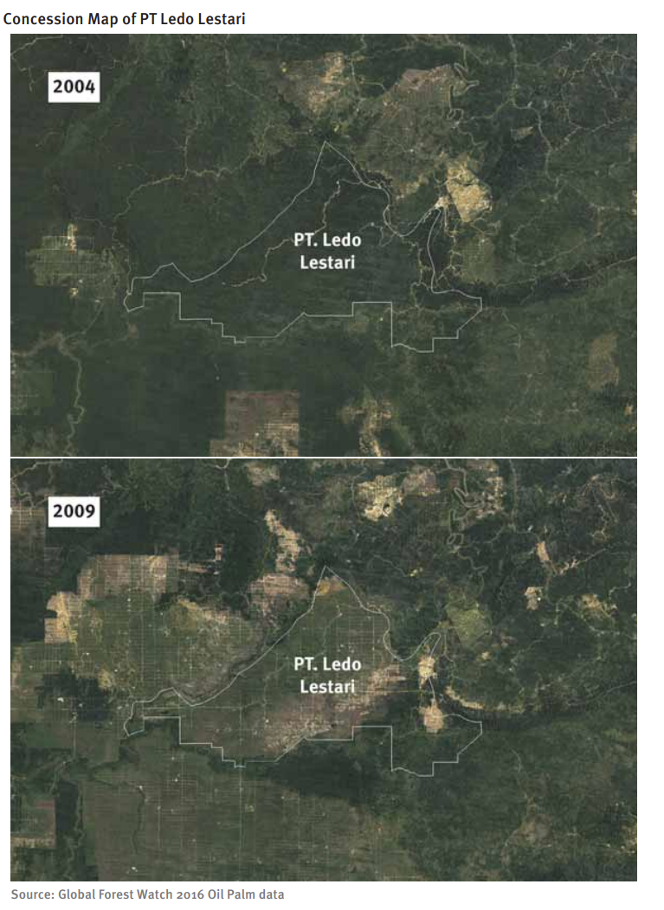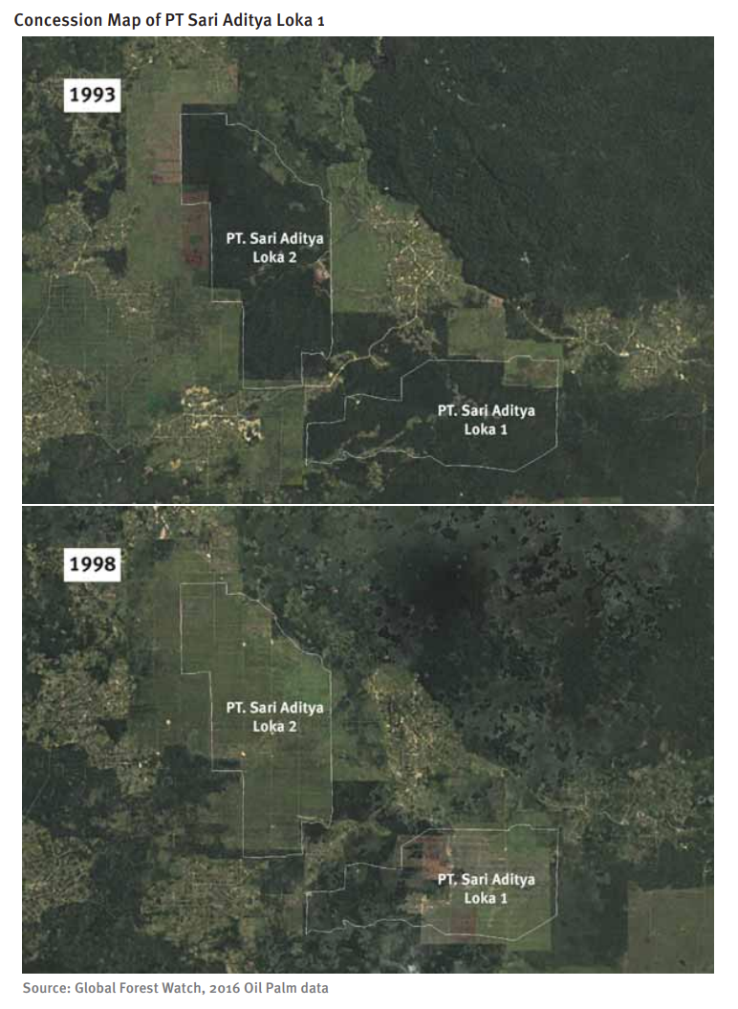

Data: Helena (30 sec)

* Our dataset comes from three sources: Golden Agri-Resources (GAR), Roundtable on Sustainable Palm Oil (RSPO), and Wilmar International.
* Within the dataset, each record contains ***metadata*** about the grievance submission and resolution as well as a ***summary*** of the allegation and ***progress updates*** reported by the mediator. Information needed to classify the grievance may be found in one or both of the summary and progress update fields
* Right now the dataset has 430 rows, but we may get more data later.

Plan of Action: Nichole (1.5 min)

* Use the five models on data with and without TF IDF weights on training data
* Use n grams in all models
* Choose models we like
* Tune those models for hyper parameters
* Run those on validation data
* See which perform best

Models:

* List all models
* Choosing num of models using coherence scoring
* Putting a very basic corpus in, with not many hyper parameters

Run w/ raw freq AND Run w/TFIDF

* What did we get from those? Topics (with top words), word clouds, distribution tables:
* Looks like this, being stored in a slide deck:
* Remember to semi explain “tfidf’’
* Show an example of two completed slide deck pages, outputs
* Contribution percentages stuff
* 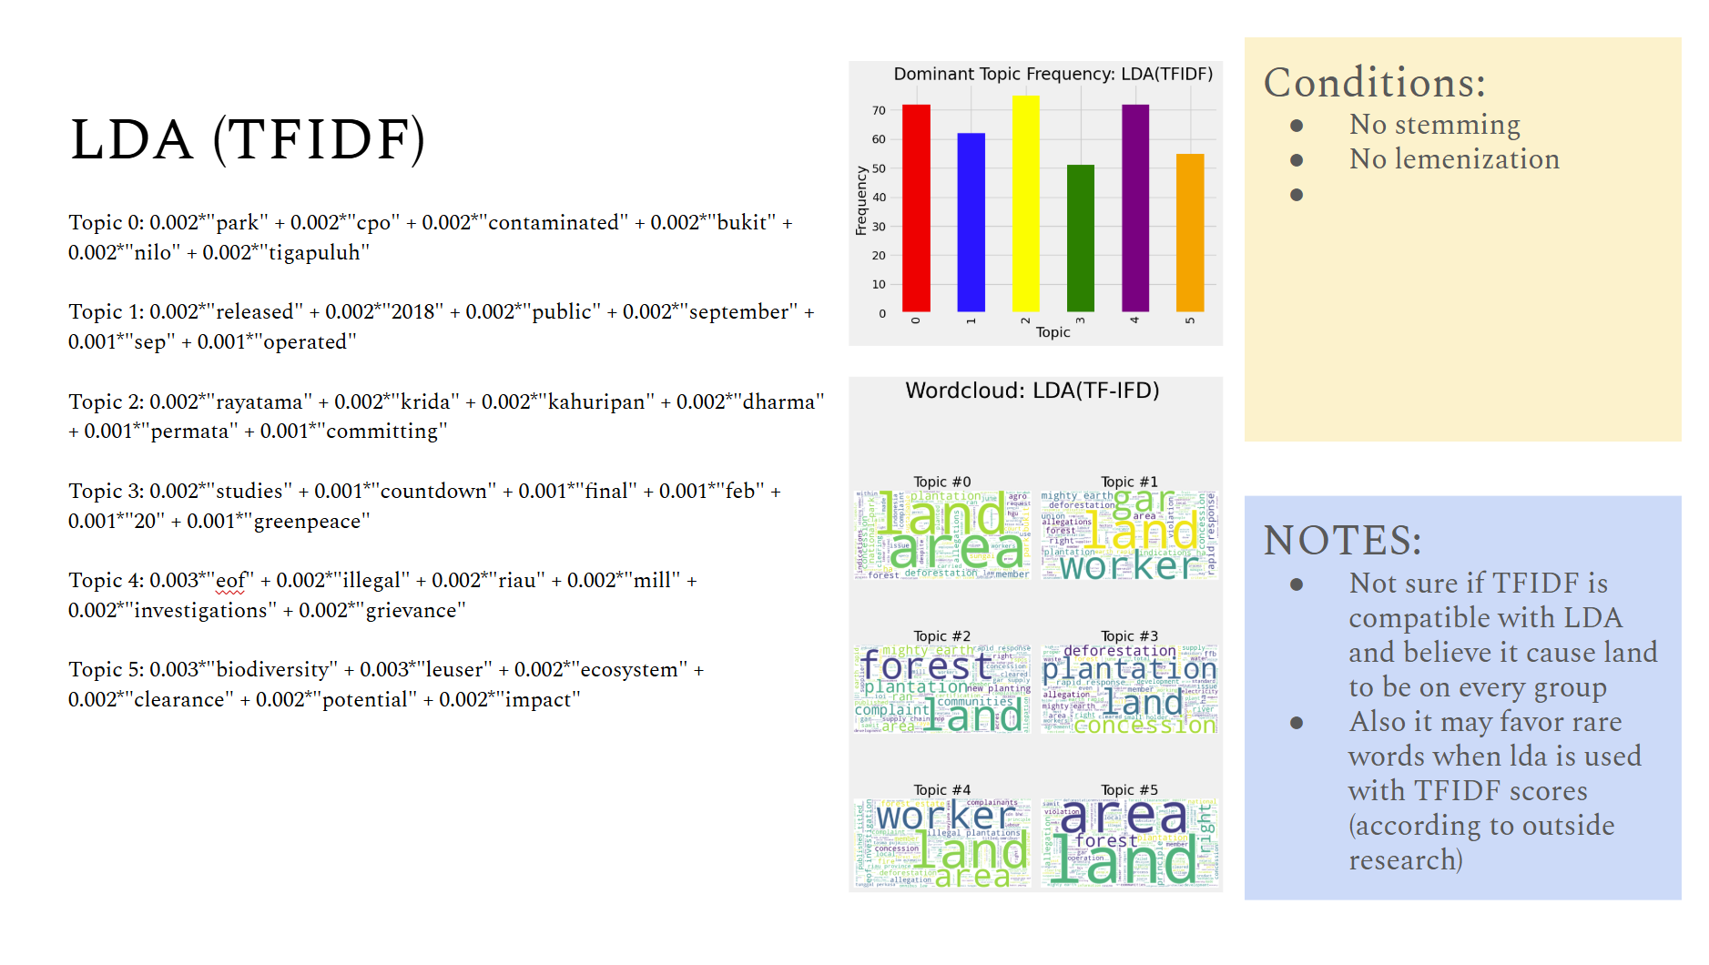
* 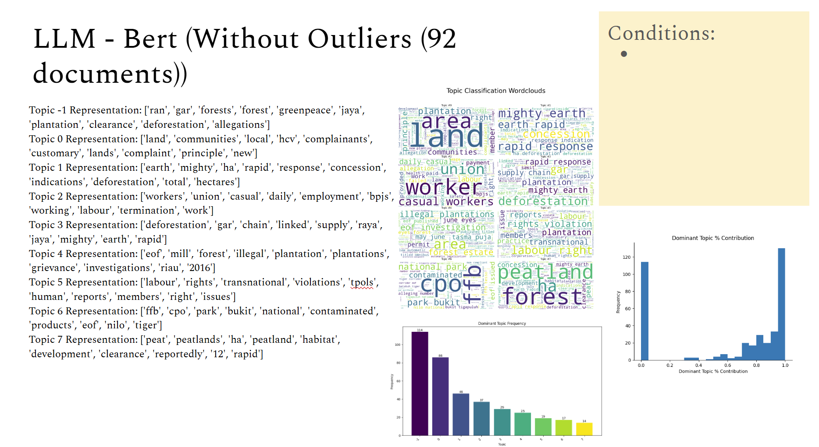
* 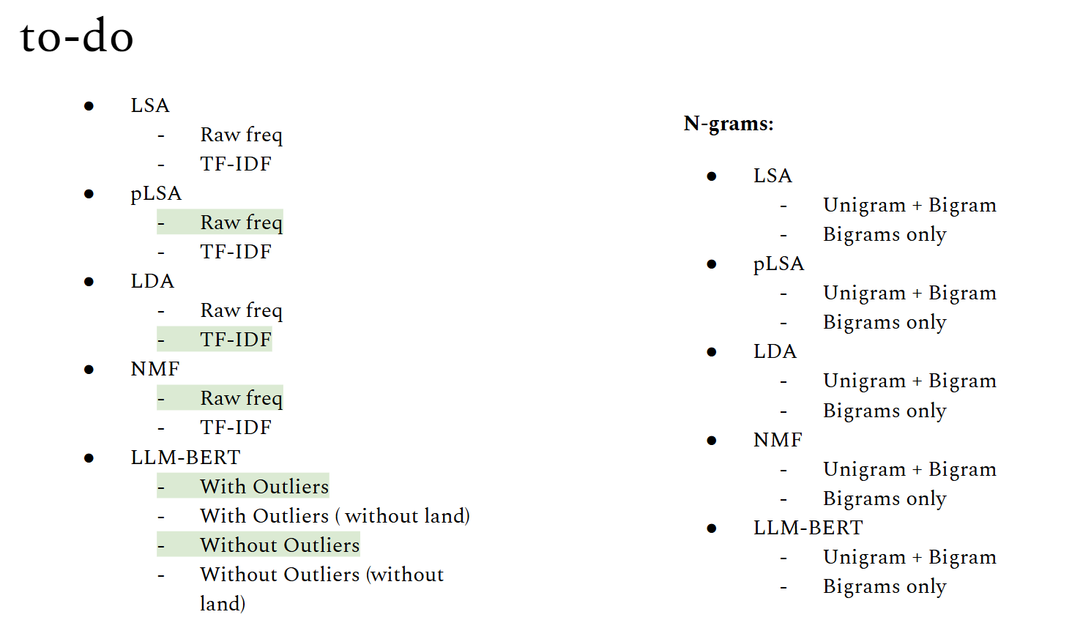

Issues:

* TFIDF was not compatible with LDA
* Dates, numbers, and company names were overcrowding
* Needed to set seed
* Bert internally chooses the number of topics
* pLSA are not compatible with TFIDF
* Don't know whether contribution percentage is definitely good indicator (look into taht

Next:

* Run n-grams on all models
* Look into topic contribution percentages
* Identify topic titles for every model
* Analyze and choose which models to ‘*’ and come back to
* For those models… address dates, lemmenization/stemming, company anmes

📑 Research Texts

"Unequal access to justice"

# PDF NOTES: Unequal access to justice: an evaluation of RSPO’s capacity to resolve palm oil conflicts in Indonesia

| **TOPIC** | **NOTATION** |
| --- | --- |
| Purpose of RPSO | * Roundtable on Sustainable Palm Oil (RPSO) * Palm oil industry growth good for economy but caused environmental problems and widespread land related conflicts * RPSO established to address negative enviro and social impacts * aim is not only to provide a ‘reality check’ regarding this mechanism but also to contribute to the wider debate on how communities can seek access to justice when engaged in intractable conflicts with palm oil companies * central question: To what extent does the RSPO conflict resolution mechanism offer an accessible, fair, and effective tool for communities in Indonesia to resolve conflicts with companies? |
| Observations about RPSO (conflict res, etc | * met a ‘demand’: the RSPO dealt with more than 150 conflicts from around the globe in the period 2009–2020 * NGOs such as Forest Peoples Program (FPP) and Oxfam have hailed the mechanism as a valuable tool for communities * analysts have criticized this mechanism for being ineffective and imperfect * RSPO’s mechanisms have very limited usage because of how complex it is to register a case. Online forms, Complaint letters with specific details, scanned docs as evidence etc. |
| 3 part Criteria for CRM Tool | Criteria 1: Recognize and Respect   * Principle that oil palm growers recognize and respect land rights, including ones based on tradition and culture   Criteria 2: Procedural Justice   * “where there is a conflict on the condition of land use as per land title, growers should show evidence that necessary action has been taken to resolve the conflict with relevant parties” * “Procedural Justice” describes fairness in political processes where actors deliberate and negotiate decisions, including environmental decisions in natural resource management and dispute resolution. (pg.293)   Criteria 3: Conflict Resolution Mechanism (CRM Tool)   * Complaint system * Non-judicial |
| RSPO: Data Sources (Pg. 292) | **Types**   1. **RSPO’s Indonesian Database** of 150 conflicts between communities and companies in Indonesia 2. **RSPO’s ‘case tracker’**, which documents RSPO’s handling of 85 complaints against companies in Indonesia in the period 2009–2020 3. **RSPO conducted in-depth fieldwork** on three conflicts involving RSPO companies to identify reasons for successful and failed conflict resolution.   **Location**   * Four Indonesian provinces: West Sumatra, Riau, West Kalimantan and Central Kalimantan. |
| Company POV | * (pg.292) “Oil palm plantations have expanded rapidly in Indonesia: between 1980 and 2019, nearly 14.5 million ha of land were converted into plantations, most of which (about 55%) are owned by private companies (Direktorat Jenderal Perkebunan 2019).” * (pg.293) Biases often creep into the rules guiding conflict resolution mechanisms, and the resolution strategy (Benda-Beckmann 1981, pp. 117–145; Gent and Shannon 2011, p. 125), creating a situation where the mechanism favors one side of the dispute (see also Kydd, 2003).   + In this case we see that the mechanism has been favoring companies so far |
| Palm Oil Community POV | * (pg.292) the palm oil plantation expansion has created economic growth but also created environmental problems and land-related conflicts * (pg.292) there are land rights and based on traditions and culture not just “by the books” * (pg.292) the “case tracker” component could be helpful to see the “follow through” or how much attention complaints are given, can also help with company accountability * (pg.293) there is an “access to justice” issue for communities, both in formal and informal justice systems   + Important to “... pay particular attention to the extent to which rural Indonesians face such obstacles when trying to bring their grievances to the attention of the RSPO.”   + “The perception of a fair decision-making process (procedural justice) can help build trust, legitimacy, and satisfaction with conflict resolution outcomes (Lind and Tyler 1988; Törnblom and Vermunt 2007).” * (pg.295) “In our study of 150 conflicts in Indonesia, we found that rural Indonesians have difficulties with the complexity of the RSPO CRM procedures and tend to prefer other mechanisms (Berenschot et al. 2022): they are more likely to rely on informal mediation provided by local politicians and bureaucrats (109 cases, or 73% of our total of 150 conflict cases), or to a lesser extent.” * ACCESSIBILITY!! * (pg.298) “Another procedural criterion of the RSPO’s conflict resolution mechanism causing difficulty for villagers (and helping companies) concerns the requirement that villagers’ organizations need to prove their formal legality by having a notary-certified deed of establishment and by being registered with the local government. Failure to submit the requested documents results in a dismissal of the villagers’ complaints.” |
| Types of Complainants | Pg 296 (**\*\*Not necessarily mutually-exclusive categories**)  -Confidential -Individual -Labor/farmers’ union  -Rep of the local community -NGO -RSPO Secretariat |
| **2 other Grievance Procedures (in addition to RSPO):** | |
| [Golden Agri-Resources (GAR)](https://www.goldenagri.com.sg/sustainability/responsible-sourcing/grievance-list-and-reports/) | * investigate grievances raised and conduct site visit to ensure responsible practices throughout our supply chain * one of the world’s largest seed-to-shelf agribusinesses * Seems like a private company that runs cite visits to make sure suppliers are upholding their guidelines, does not buy from the supplier if they are deemed non-compliant * [grievance procedure](https://www.goldenagri.com.sg/sustainability/responsible-sourcing/grievance-handling/) * Columns include no., group, reported company, summary of case, source, date, and status * Website includes detailed grievance reports listing violations and plan of action * [Example site visit report](https://goldenagri.com.sg/sustainability-dashboard/files/file_docs/Bb9FOfield_visit_report_re_hpi_agro_grievance_.pdf) |
| [Wilmar International](https://www.wilmar-international.com/sustainability/grievance-procedure) | * Addresses grievances from parties, including individuals, government organizations, and non-governmental organizations, concerning the implementation of Wilmar’s No Deforestation, No Peat, No Exploitation (NDPE) Policy. |
| Procedures: | 1. RSPO: <https://www.rspo.org/wp-content/uploads/brochure-rspo-complaints-appeals-procedures-english.pdf> 2. Wilmar: <https://www.wilmar-international.com/docs/default-source/default-document-library/sustainability/grievance/grievance-sop/grievance-procedure_final.pdf?sfvrsn=7670cea2_4> 3. GAR:   <https://goldenagri.com.sg/sustainability-dashboard/files/file_docs/2KXOGgargrievance_procedure_thirdparty.pdf> |

Current Issues with CRM:

* (pg.292) “ analysts have criticized this mechanism for being ineffective and imperfect (Chao 2013; Macdonald and Balaton-Chrimes 2016).”

# RSPO (Roundtable on Sustainable Palm Oil) Conflict Resolution Mechanism (CRM) - three main channels:

1. **RSPO Secretariat**

Role: Central coordinating body for complaints.

Functions:

Receives, reviews, and classifies complaints.

Conducts preliminary diagnosis to check if the complaint falls under RSPO jurisdiction.

Communicates with both complainant and respondent (usually the palm oil company).

Facilitates the entire process from submission to closure of the case.

Limitations: Can dismiss complaints if required documents aren't submitted in time.

1. **Complaint Panel (CP)**

Role: Main decision-making authority in the CRM process.

Composition: Made up of representatives from RSPO constituencies (e.g., NGOs, growers, financial institutions).

Functions:

Issues interim and final decisions on complaints.

Can dismiss complaints or issue directives to companies to address grievances.

Decides whether a complaint proceeds after company and complainant responses.

Handles appeals against initial (interim) decisions.

Criticism: Heavily relies on company responses without verifying claims; rarely gives complainants a chance to rebut company submissions.

1. **Dispute Settlement Facility (DSF)**

Role: Provides mediation services for complaints.

Functions:

Offers voluntary mediation if both parties agree.

Arranges and facilitates the mediation process.

Does not mediate directly—it recruits independent mediators.

Originally focused on land disputes, but now also includes labor, environmental, and human rights issues.

Limitations: Not mandatory and effectiveness depends on company cooperation.

# Problematic Cases Described in Journal:

**1. Desa Kapuk vs. PT BSK II (Central Kalimantan)**

Issue**:** Unpaid compensation for 78 hectares of land.

What happened**:**

Community submitted a complaint with NGO help.

Company claimed compensation was already paid collectively.

RSPO accepted this explanation without verifying individual payments.

Community failed to appeal; complaint dismissed.

**2. Pondok Damar vs. PT Mustika Sembuluh (Wilmar Group)**

Issue**:** Land taken without consent; joint-venture (plasma) not delivered.

What happened**:**

Community tried RSPO after years of failed protests and mediation.

Couldn’t submit required GPS data and notary documentation.

Case dismissed due to missed deadline.

**3. Biru Maju vs. PT BAS**

Issue**:** Land taken without consent and pollution; arrests after protests.

What happened**:**

NGO filed complaint.

RSPO facilitated a bilateral agreement: company would give different land in exchange.

Promised land turned out to be in protected forest; company didn’t follow through.

Agreement not implemented years later.

**4. Kapa Community vs. PT PHP1**

Issue: Customary land rights not respected.

What happened:

RSPO initially dismissed complaint.

With help from NGO Forest Peoples Programme (FPP), community successfully appealed.

RSPO commissioned a study on land rights and facilitated mediation.

Agreement was reached and implemented.

**5. PT Bumitama Gunajaya Agro (BGA) vs. 12 Villages**

Issue: Plasma land agreements made without proper consent.

What happened:

Complaint filed by villagers with NGO support.

RSPO accepted company’s claim that it was an internal cooperative issue.

RSPO dismissed complaint; no further investigation; no appeal filed.

**6. PT MAS (Sime Darby) vs. Sanggau Communities pg 298**

Issue: Land taken without consent.

What happened:

RSPO asked company for land transfer documents.

Company repeatedly refused or delayed providing them.

RSPO issued no consequences.

Case remained unresolved for 8 years.

**7. Multiple Companies (e.g., Genting Plantations subsidiaries) vs. various communities**

Issues: Transparency, land rights, environmental violations.

What happened:

Some complaints dismissed due to procedural errors.

Others dismissed based on company-provided reports (without field verification).

NGOs often barred from appealing or seen as not representative.

"When We Lost the Forest, We Lost Everything"

PDF NOTES: When We Lost the Forest, We Lost Everything

| Summary, Key Recommendations, Methodology |
| --- |
| * “Palm oil derivatives make their way into many grocery store products including frozen pizzas, chocolate and hazelnut spreads, cookies, and margarine. They are also used in manufacturing numerous lotions and creams, soaps, makeup, candles, and detergent. Crude palm oil is also processed into a biodiesel blend used in vehicles and industrial machinery.” pg.12 * Complex web of domestic and international companies are involved in growing fruit, converting to oil, manufacturing ingredients, and producing consumer projects * The expansion of palm oil plantations in indonesia has adversely affected indigenous people’s rights to their forests, livelihood, food, water, and culture * There are 2 companies the Human Rights Watch focused on for plantation operations: PT Ledo Lestari in Bengkayang regency of West Kalimantan province, and PT Sari Aditya Loka 1 in Sarolangun regency of Jambi province * What's causing these issues??, “A patchwork of weak laws, exacerbated by poor government oversight, and the failure of oil palm plantation companies to fulfill their human rights due diligence responsibilities, have resulted in loss of land and livelihood opportunities for Indigenous people in West Kalimantan and Jambi in the projects we researched.” pg.12 * Indonesia has 14 hectares of land planted with oil palm (no clear estimate of hum of land disputes or displaced households) * Deforestation on this large of a scale has a global significance, as it contributes to carbon emissions and climate change * “Indigenous peoples have an intrinsic relationship with their environments. Their traditions, knowledge, and cultural identity are deeply connected to the natural environments in which they live. Any disruption to their natural environments, as in the case of the Ibans and the Orang Rimbas, affects their culture, languages, knowledge, and unique traditions” pg.15 * There have been lots of issues with companies giving verbal promises to communities that they do not follow up with. Such as promises of health clinics or amenities. * Whiel companies have requirements about consulting with affected communities, they often fail to do so. Pg.18 * “The oil palm plantations not only destroyed Indigenous people’s forests, lands and the resources in them that they were using for generations but also failed to create any mechanism to explore restitution or provide just and fair compensation for losses suffered, in consultation with the Indigenous people impacted.” pg.20 * “ability to continue to harvest within their yards, land titles, shares from a plasma, or community plantation, that the company would set up, and other amenities including health clinics and schools, to lure them to leave the area.” pg. 20, these were promised but not materialized by companies. * One company, PT Ledo Lestari , did engage in some consultations which included conversations about family land and payouts but they do not seem to have included women in those discussions. * “Francesca, a 28-year-old mother of two, stands on the site of her former home. She and her husband refused relocation. She said that company representatives torched her home in 2010, rendering them homeless. Bengkayang regency, West Kalimantan, September 2018.” pg.20 * The companies and their security guards have even gone so far as to call some of the indigenous people “thieves” * “Today, in Jambi province in central Sumatra, the Orang Rimba community lives in abject poverty. Many have been left homeless, live in plastic tents, and without livelihood support. The Orang Rimba Human Rights Watch interviewed said that they had once been self-sufficient but are now reduced to begging on the highway or “stealing” oil palm fruits from the plantation area to sell and make money.” pg.24 * Water pollution is making one self sufficient communities be forced to buy fish and search for fish in waters they once fished i easily * “PT Agro Astra Lestari, the parent company of Sari Aditya Loka 1, which operates the oil palm plantation in Jambi Province, has a host of policies on sustainability, traceability, and grievance redress, that apply to all its subsidiaries and oil palm plantations.” pg.24 * “PT Ledo Lestari, which operates the plantation in Bengkayang, West Kalimantan, does not have any published policies on sustainability or the protection of Indigenous people’s rights. It has also not engaged with Human Rights Watch or local NGOs.” pg 24-26 * (Needed Government Reforms) pg.26-27   + “Customary rights of Indigenous people are lost in a maze of laws that were designed to protect them but do the opposite. As a result, Indonesia’s Indigenous people struggle to have their rights to customary land recognized. “ pg.26   + Many areas have been mapped but few legal certificates have been issued   + “Adopting new laws and a high-level commission are critical to ensuring the success of Jokowi’s 2018 “Complete Systematic Land Registration until 2025” program. The World Bank-funded initiative aims to register all land in Indonesia by 2025. “ pg.27 * Pg.28 key recommendations:   + TO THE INDONESIAN GOVERNMENT • Urgently recognize and protect Indigenous peoples and their community rights to land and forests. • Revise the Indonesian Sustainable Palm Oil (ISPO) certification system to align with international human rights standards. • Establish a Land Dispute Resolution Mechanism.   + TO OIL PALM PLANTATION COMPANIES IN INDONESIA • PT Ledo Lestari and PT Sari Aditya Loka 1 should initiate mediation with affected communities and Indigenous peoples to resolve long standing grievances, and offer compensation or remediation to those affected. • All companies operating plantations should carry out robust human rights due diligence and provide just, fair, and equitable compensation in accordance with international human rights standards.   + TO OIL PALM IMPORTING COUNTRIES • Require companies to be transparent about their palm oil supply chains.   + TO DONORS • The World Bank and other donors should support the Indonesian government in carrying out the reforms needed to protect community and Indigenous people’s rights to land. * Methodology   + Report from 2018, 11 weeks, february to september   + Focused on palm oil plantation disputes and indigenous people claims in Kalimantan and Sumatra   + Human Rights Watch conducted interviews with 00 pus people from communities, and lawyers, and NGO representatives working on conflicts   + “. Of these interviews, 57 were with ethnic Iban Dayak and Orang Rimba people, of which 42 were with women. Human Rights Watch conducted four interviews in groups of 3 to 10 people; all others were individual interviews.: pg.29   + “In August 2018, Human Rights Watch sent letters explaining our research and a list of questions requesting information to both PT Ledo Lestari and PT Sari Aditya Loka 1. The companies did not respond to our letters. In June 2019, Human Rights Watch hand delivered another set of letters to both companies explaining our findings and including a list of questions. Letters were also emailed to PT Sari Aditya Loka 1 in August 2018 and June 2019. PT Ledo Lestari has not responded. In August 2019, Human Rights Watch received a letter via email from Bandung Sahari, vice-president of sustainability at PT Astra Agro Lestari Tbk.” pg. 29   + Reviewed primary data sources, including laws, ministerial regulations, three court decisions, and other legal documents |

1. **Indonesian Palm Oil and Land Conflicts**

* Foreign, dometics, private and state own companies buy and develop land for oil palm plantations
* Indonesia is the world's top palm oil producer and exporter
* 40 billion plus tones
* Over half of the world's total production
* Palm oil production is projected to grow in the coming years, propelled by the global demand for biodiesel.
* Although not in the EU
* The EU has announced a cap on all palm oil imports for biofuel at 2019 levels until 2023, and a total phase-out by 2030.
* Rapidly declining forest cover pg.32
  + “Between 2001 and 2017, commercial ventures in Indonesia destroyed more than 24 million hectares of its tree cover, an area nearly as large as the United Kingdom.” pg.32
  + The forest that have been cleared and burn for oil palm and paper pulp plantations have cause air pollution and natural carbon sinks
  + Respiratory health across the region has been affected
  + Spike in carbon emissions
* Pervasiveness of Land Conflicts
  + Indonesia has 50 to 70 million indigenous people, quarter of population
  + Land disputes are with the indigenous people living in or around the forests
  + “Over the years, these conflicts have continued, exacerbated by a combination of poor protection for Indigenous peoples’ land rights and complex land governance systems that fail to prevent or resolve disputes.” pg. 34
* Indigenous Peoples’ Struggle to be Legally Recognized
  + “At the heart of land conflicts involving Indigenous peoples and corporations lies the struggle of various Indigenous groups for legal recognition of their identity and collective rights. Local nongovernmental organizations (NGO) have repeatedly called for effective, streamlined, and time-bound procedures to recognize and protect Indigenous peoples’ land rights.” pg. 35
  + There are over 2330 distinct indigenous communities, but no official daton how many are legally recognized
    - “One NGO noted that authorities recognized 18 Indigenous communities between 2015 and 2017.” pg. 35
  + “Indonesia’s constitution and laws recognize that adat (literally, custom or tradition) communities exist and affirm their communal rights to land.24 In practice, realizing these rights entail cumbersome processes in which Indigenous groups have to prove their existence and register their land rights. Without legal recognition, groups that self-identify as Indigenous cannot register collective rights to land.” pg. 36
  + The rights of indigenous people are lost in a “maze of legal procedures” that were designed to protect them but actually have been making things harder.
    - Indonesian laws since 1999 aim to protect Indigenous land rights but are complex and hard to follow.
    - Indigenous groups must apply for legal recognition, but most local governments don’t have procedures in place.
    - Where procedures exist, they require meeting 4–7 criteria and can take years to process.
    - Even after recognition, communities must apply separately for land, forest, and cultural rights at multiple government levels.
    - As of 2018, over 1,100 territories (14+ million hectares) were mapped by NGOs but few are officially recognized.
    - In West Kalimantan, only two communities have registered their land rights.
    - A 2013 court ruling confirmed Indigenous rights to customary forests but it has been poorly implemented.
    - In 2015, the government pledged to recognize 5 million hectares of community forests only about 32,791 hectares have been approved as of 2019.
    - President Jokowi’s handover of 29,500 hectares to 18 groups fell far short of promises.
    - A 2018 moratorium on new palm oil permits aimed to protect forests but systemic issues persist.
    - Overall, Indigenous peoples face a bureaucratic maze, delays, and a lack of political will to secure their rights.
* Key Legal Processes and Responsibilities of Plantation Companies
  + Required Permits (in order):
    - Location permit (Izin Lokasi): Issued by local authorities after checking land rights.
    - Environmental & social impact assessment (AMDAL): Required before operations.
    - Environmental permit (Izin Lingkungan): Based on AMDAL results.
    - Plantation business permit (IUP): Granted by district/provincial government.
    - Forest conversion permit: If land overlaps with forested areas
    - Right to Cultivate (HGU): Final permit from provincial land office.
  + Consultation Duties (required before permits):
    - Before location permit: Inform community, assess social/environmental impacts, gather feedback.
    - Before environment/plantation permit: Consult with community; unresolved issues can be escalated to an appraisal commission.
    - Before HGU permit: Negotiate land transfer and compensation with rightful landowners, including Indigenous communities.
  + Problems in Practice:
    - Consultations are often rushed or skipped, with poor oversight from authorities.
    - Community members are sometimes uninformed until after permits are issued.
    - New online permit systems speed up approval but may weaken accountability.
  + Additional Legal Responsibilities:
    - Compensation: Required for communities losing land access.
    - Plasma plantations: Companies must allocate at least 20% of cultivated land to local communities via profit-sharing or cooperative partnerships.
  + While laws are in place to protect community rights, in reality, enforcement is weak, consultations are often bypassed, and communities frequently receive little benefit or involvement in the process.

1. **The Human Cost of Oil Palm Plantations**

* Human Rights Watch researched the development and operations of palm oil plantations in : West Kalimantan and Jambi in central Sumatra
  + Both started over a decade ago and are still operating today
  + The research found that neither companies have followed domestic laws and internation human rights standards
  + “The Indigenous communities are still grappling with serious impacts on their human rights to a livelihood, access to food and water, and culture. To date, they have not been adequately compensated for their loss. The loss especially to Indigenous women has been ignored.” pg. 45
* Case 1: PT Ledo Lestari, West Kalimantan Province
  + “The forest used to supply all our needs. Now if the rains come, everything floods. The forest is gone. There is no way to hold back water. We can’t plant anything. We lost everything to palm oil.”

—Lindan, 58-year-old mother of three with five grandchildren, Semunying Bongkang, May 2018

* + “Forest means everything. Forest provides water. Water is blood … land is body, wood is breath. When we lost the forest, we lost everything. We can’t pray to the god of oil palm.”

—Mormonus, village leader, Semunying Jaya, May 2018

* Pg.45
* pg. 46
* PT Ledo Lestari did not properly consult communities before operations, which would have been in violation with indonesian laws
* Residents of the community didnt realize that operations were beginning until they saw bulldozers
* When a resident asked what teh bulldozers were for tehy were told it was for building a state road
* Villagers realised they were given false information when more workers arrived and began to cut through forests, rice fields, and tree farms while exaning their construction camp
* There were protestsand teh government brough in military with guns to intimidate villagers and stop them from stopping company operations
* Two village leaders were detained after protests
* Someone who introduced himself as teh director of PT Duta Palm Nusantrara group overerred them aid and money if thy supported the oil palm plantation
* Some government groups were started to help represent the villagers but no actiall leaders of the villagers or communities were in the roles
* Inadequate Compensation and Unfulfilled Rehabilitation Promises
  + PT Ledo Lestari negotiation compensation with families but most was not properly fulfilled
  + There were oral promises of land titles, benefits from a “plasma” plantation, and other amenities, including health clinics and schools.
  + They only compentated SOME families for their losses of land with rubber trees and rice crops.
  + Those who received compensation reported receiving between IDR 1 million and 2 million (US$70 to $140) per hectare per family
  + Families do not know how this loss was quantified
  + The company ended up relocating the families: 21 families into permanent housing (constructed concrete buildings with metal sheet roofing) in another location in the plantation. It placed 11 other families in “company camps” scattered around the plantation and who still await permanent homes.
* “Semunying Bongkang residents told Human Rights Watch that the resettlement followed written “agreements” families were expected to sign. Residents said that some weeks later people they identified as company representatives burned houses at the original site even before residents had removed all their belongings. Francesca, a 28-year-old mother of two, said she and her husband refused relocation and declined the “agreement.” She said that company representatives torched her home, rendering them homeless:

“An assistant manager came to my home. On that day my oldest son had fever. He said to my husband, “Your five hectares of land here is gone and two hectares here is gone. Go to the company and get your money.” My husband told them he doesn’t want to sell. Months later, while I was at my mother’s new house [in the plantation] and my husband was away in Malaysia, we heard a loud noise and could see smoke. I went to see, and it was crazy. My house was already burned. Everything was in there, my son’s bicycle, clothes, and all the wood we planned to build a house, all was gone.”” pg. 55

* “Many of those who signed the “agreement” said they felt compelled to do so because their forests were already cleared.106 Susanti, a 37-year-old single mother of four, said:

“The [company] cleared the land and said I must move to another place. I had to sell my land or let them take it with no pay. I did this to survive. They [company] did not provide transportation for me to move my things [to new location]. They burned my wood and belongings I left behind.”” pg. 55

* The “Plasma” Plantation Promise Unment
  + Plasma plantations were offered to villagers and used a a key “selling point”
  + Although almost all of the promises that came alongside them were unmet
  + There were promises of concrete houses, schools and plasma, all umnment
  + “The oil palm plantations continue to have a devastating impact on the livelihoods of communities, especially women, and on their access to food, potable water, and their culture.” pg. 57
* Livelihood
  + Pre-plantation life: Iban Dayak communities lived off fishing, rice farming, and rubber tapping; sold natural goods for extra income.
  + Impact of deforestation: PT Ledo Lestari’s forest clearing destroyed local livelihoods without adequate compensation.
  + Employment gap: Only 10 out of 93 affected households were employed by the company, earning low daily wages ($4.25–$5.65).
  + Rising costs: Families must rent farmland farther away, increasing financial strain; many are worse off than before.
  + Women's challenges: Women face barriers accessing farmland, do hard labor for low pay, and struggle to fund their children’s education.
  + Educational impact: Families can't afford school costs; children drop out due to expenses like transportation and uniforms.
* Food and Water
  + Food insecurity: Loss of farming and hunting grounds reduces food availability; rice harvests fail due to bird attacks.
  + Fishing decline: Fish populations declined; residents blame pollution from palm plantations.
  + Polluted rivers: Residents report skin issues and discoloration of water linked to pesticides and effluents.
  + Water scarcity: Forest destruction and irrigation rerouting dried up streams; water must now be piped or collected during rain.
  + Community displacement: Semunying Bongkang residents relocated within the plantation lack clean water access.
* Culture
  + Cultural erosion: Loss of forests severed ties to sacred adat land used for rituals, harvesting, and communal knowledge.
  + Weaving tradition dying: No natural materials available to teach new generations; motifs and stories risk extinction.
  + Loss of community: Displacement broke social bonds; new resettlements feel like shelters, not home.
  + Unacknowledged grievances: PT Ledo Lestari has not responded to residents' complaints or Human Rights Watch outreach.
* Case Study 2: PT Sari Aditya Loka 1, Jambi Province in Central Sumatra
  + Operations began three decades ago
  + Human Rights Watch interviewed 31 Orang Rimba men and women who live in PT Sari Aditya Loka 1 plantation areas in Sarolangun regency.
  + Many Orang Rimba were pushed to live in the national parks because of paml oil productions
  + pg. 68
  + Ongoing Adverse Human Rights Impacts
    - PT Sari Aditya Loka 1 have not adequately corrected the harms its operations have caused to the Orang Rimba
    - Orang Rimba report that there was no discussions with government officials or company representatives before land and forests were cleared and planted
    - “Since the oil palm plantation operations began, the Orang Rimba have lived in the area without proper rehabilitation. Many Orang Rimba have been compelled to live in small groups of 5 to 10 families, pitching sudungs (a sheet of plastic tied to posts) in oil palm plantations, hurriedly moving frequently when discovered and chased by company employees. Human Rights Watch researchers witnessed several Orang Rimba women and children begging along the highway.” pg.63
  + Orang Romba ; An Indegenous People
    - The Orang Rimba are a semi-nomadic Indigenous people with their own customs, forest-dependent livelihoods, religious beliefs, and community decision-making structures.
    - The government created a national park, Bukit Duabelas National Park, as a measure to mitigate forest and biodiversity loss; but Orang Rimba and WARSI said the company did not meet their human rights responsibilities by not compensating or returning land to Orang Rimba.
    - In response to the claim that companies didnt have adequate consultation and compenetation the company have simply responded saying that they “obtained the relevant permits”
  + Livelihood
    - The Orang Rimba traditionally relied on the forest for rattan, dragon’s blood resin, food, and materials to trade with neighboring villages.
    - Deforestation from PT Sari Aditya Loka 1’s palm oil operations disrupted these subsistence and trade-based livelihoods.
    - Very few Orang Rimba were hired by the company, with most jobs going to non-Indigenous transmigrant workers.
    - Although the company claims to have offered training and small economic programs (e.g., fish farming, ginger cultivation), these efforts have had limited success or reach.
    - Orang Rimba face discrimination when trying to access employment or integrate into neighboring communities, discouraging participation, especially among women.
  + Women Reduced to Begging and Scavenging
    - With no land or reliable employment, some Orang Rimba women and children are forced to beg along highways.
    - Others scavenge fallen oil palm fruit to sell for minimal income, often risking confrontation with company security guards.
    - Camps are frequently raided and dismantled by plantation security, creating dangerous conditions for vulnerable individuals, including the sick and pregnant.
    - Hunger and lack of income force families to go days without proper meals, sometimes eating only boiled palm fruit.
  + Food
    - Before the plantation, Orang Rimba gathered forest produce, hunted, and were self-sufficient.
    - Now, they must purchase food from village markets but often lack the money to do so.
    - Some families resort to stealthily collecting and selling oil palm fruit, though this is considered theft by the company and can lead to confiscation or arrest.
    - Company-provided food aid (e.g., monthly rice packages) reaches only some individuals and is not a sustainable or empowering solution.
  + Culture
    - The clearing of the forest has erased sacred spaces and rituals tied to birth, death, and prayer, severing cultural traditions.
    - Traditional birthing and burial customs are no longer practiced due to lack of forest space and access.
    - Orang Rimba have lost the ability to pass down knowledge and practices tied to the land, including medicinal plant use and spiritual symbols.
    - Displacement has pushed families into makeshift shelters, disrupting communal cohesion and traditional housing.  
      While the company claims to have a respectful policy regarding interactions with the Orang Rimba, there is no evidence of active enforcement or accountability.

1. **Key Land Governance Issues**

* Failure to hold Corporations Accountable
  + Prompt and meaningful government measures would both prevent and remedy corporate abuses that affect Indigenous people but in the research there was no indication that indonesian authorities were holding companies responsible
* Urgent Bills Languish
  + The laws and regulations surrounding land rights procedures are very ocnfusing, condridictary, and have lots of overlap
  + There are two proposed laws which could help this situation and simplify the problem
    - The Land Rights bill could clarify the role and authority of various government institutions related to land.
    - The draft law on the Recognition and Protection of Indigenous Peoples’ Rights aims to simplify the process for recognizing specific Indigenous peoples and their territories. The draft law would also set a path toward the resolution of many of Indonesia’s land disputes.
* Unresolved Land Conflicts
  + “Communities struggling to resolve land conflicts have found a lack of coordination among ministries crucial to resolving them.” pg. 80
    - National Land Agency of the Ministry of Agrarian and Spatial Planning
    - Ministry of Environment and Forestry
    - Home Affairs Ministry
  + Because of teh disorganization between tehse groups, some cases have become near impossible to get to the bottom of
* Poor Data Collection and Lack of Transparency
  + no clear tracking of the numbers of land conflicts, their status, and whether they are resolved, outside of the mediated cases that have been analyzed

1. **International Human Rights Law**

* Right To Culture and Partticipation
  + The UN Declaration on the Rights of Indigenous Peoples (UNDRIP) affirms Indigenous peoples' rights to:
    - Maintain cultural, political, legal, and social institutions.
    - Be free from dispossession of lands and resources.
    - Participate in decisions affecting their rights.
  + States must ensure free, prior, and informed consent (FPIC) before actions affecting Indigenous communities.
  + International law protects traditional ways of life impacted by environmental change (e.g., hunting, fishing).
* Land Rights and Protecction from Dispossession
  + Indigenous peoples’ land rights include collective ownership, use, and control based on traditional occupation.
  + Governments must:
    - Legally recognize and protect communal lands.
    - Prevent dispossession or displacement.
    - Provide redress, including restitution or fair compensation, when dispossession occurs.
  + Land rights do not require formal legal title; traditional use counts.
* Economic and Social Rights
  + International treaties (like the ICESCR and ICCPR) protect:
    - Right to food
    - Right to water
    - Right to housing
    - Right to health
    - Right to an adequate standard of living
  + These rights include safe, accessible, and affordable basic needs, even in the absence of formal land tenure.
* Right to Redress and Compensation
  + When Indigenous peoples lose lands or cultural property, they are entitled to:
    - Restitution where possible
    - If not, just, fair, and equitable compensation
    - Compensation can be in the form of equivalent land, money, or other resources.
* Human Rights Responsibilities of companies
  + Under the UN Guiding Principles on Business and Human Rights, companies must:
    - Conduct human rights due diligence (HRDD)
    - Identify and address actual and potential harms
    - Avoid contributing to abuse and remediate when harm occurs
  + Due diligence should be ongoing and focused where risks are highest.
  + Business responsibilities apply to:
    - Plantation companies
    - Mills
    - Brands and manufacturers further down the supply chain

🧼 CSV Sanitization

| **ISSUE TYPE** | **COLUMN** | **LABEL** |
| --- | --- | --- |
| Duplicates | respondent_parent_company | Golden Agri-Resources (GAR)  Golden Agri Resources Ltd  Compañia Industrial Aceitera…  Compañía Industrial Aceitera…  Permata Group Pte. Ltd  Permata Group Pte. Ltd.  IOI Corporation Berhad  Musim Mas Holdings Pte.  Musim Mas Holdings Pte. Ltd. |
| Inconsistencies | submitted_on & last_updated_on | Times don’t make sense since last_updated_on |
| Duplicates | respondent | Green= NOT duplicates  Red= Duplicates  **BOLD=** Use this name to standardize if duplicate   * ACEITES S.A. * ACEITES Y DERIVADOS SOCIEDAD ANONIMA (ACEYDESA) * Agrindo Green Lestari and Citra Agro Abadi, subsidiaries of Ciliandry Anky Abadi (CAA) Group * **Agrindo Green Lestari; Citra Agro Abadi** * Andalan Sukses Makmur (ASMR) * **Andalan Sukses Makmur; Gunajaya Harapan Lestari; Hati Prima Agro; Langgeng Makmur Sejahtera; Damai Agro Sejahtera; PT Lestari Gemilang Intisawit** * Andika Permata Sawit Lestari * **Andika Permata Sawit Lestari (APSL)** * Arrtu Energi Resources * **Arrtu Energie Resources** * Arta Prigel * **Artha Prigel, a subsidiary of Bukit Barisan Indah Prima** * Ensem Sawita * Ensem Sawita (for allegedly sourcing from Agra Bumi Niaga) * First Resources * First Resources Limited * Gemilang Sawit Kencana * Gemilang Sawit Kencana, a subsidiary of Hartono Plantation Indonesia (HPI Agro) * Golden Agri-Resources * Golden Agri-Resources Ltd * Golden Veroleum (Liberia) Inc. (GVL) * Golden Veroleum Liberia * Hardaya Inti Plantation * Hardaya Inti Plantation (HIP), a subsidiary of Hardaya Plantations Group (HPG)   Started checking country first:   * IJM Plantations   ~ no region/country   * IJM Plantations Berhad   ~ Sabah, Malaysia   * IOI   ~ no region/country   * IOI Corporation Berhad (IOI)   ~ no region/country   * IOI Plantation Mekassar Estate   ~ Maudzam Shah, Pahang   * IOI PELITA PLANTATION SDN BHD   ~ Miri, Sarawak   * IOI Pelita; Kalimantan Prima Agro Mandiri; Bumi Sawit Sejahtera; Berkat Nabati Sejahtera   ~ no region/country   * Kahayan Agro Plantation   ~ no region/country   * Kahayan Agro Plantation (KAP), a subsidiary of Anglo-Eastern Plantations   ~ no region/country   * Kumai Sentosa (Kumai Sejahtera)   ~ no region/country   * Kumai Sentosa, a subsidiary of Gagah Putera Satria (GPS)   ~ no region/country   * LKPP Corporation Sdn Bhd * LKPP/PKPP/YP Plantation * Medco Papua Hijau Selaras * Medco Papua Hijau Selaras, a subsidiary of Capitol Group |
|  |  |  |

**Respondent parent companies (unique values might be repeated):**

[' IOI Corporation Berhad',

' Permata Group Pte. Ltd',

'AAA Oils & Fats Pte. Ltd.',

'BUMITAMA AGRI LTD',

'Boustead Plantations Berhad',

'Cargill Incorporated',

'Compañia Industrial Aceitera Coto Cincuenta y Cuatro S.A',

'Compañía Industrial Aceitera Coto Cincuenta y Cuatro S.A.',

'Control Union (Malaysia)',

'Daabon Group',

'Extractora la Gloria SAS',

'First Resources Limited',

'Genting Plantations Berhad',

'Golden Agri-Resources (GAR)',

'Golden Agri-Resources Ltd',

'Goodhope Asia Holdings Ltd.',

'HOLDING LA FABRIL S.A. HOLDINGFABRIL',

'Herakles Farms Coöperatief',

'IOI Corporation Berhad',

'KH Regional Group Inc.',

'Kuala Lumpur Kepong Berhad',

'M.P. Evans Group PLC',

'Musim Mas Holdings Pte.',

'Musim Mas Holdings Pte. Ltd.',

'Noble Plantations Pte Ltd',

'Oleoquímica Mexicana S.A. de C.V.',

'PT Dutapalma Nusantara',

'PT Ibris Palm',

'PT Musim Mas',

'PT Permata Hijau Group',

'PT Salim Ivomas Pratama Tbk',

'PT. Austindo Nusantara Jaya Agri',

'PT. Bakrie Sumatera Plantations TBK',

'PT. DHARMA SATYA NUSANTARA',

'PT. Eagle High Plantations Tbk',

'PT. Inti Indosawit Subur',

'PT. Pasifik Agro Sentosa',

'PT. Sawit Sumbermas Sarana',

'Permata Group Pte. Ltd.',

'Poligrow Colombia SAS',

'R.E.A. Holdings Plc',

'S&G BIOFUEL PTE. LTD',

'SD GUTHRIE BERHAD',

'SEAHOLM CORP',

'SIAT SA',

'SIPEF Group',

'SOCFIN SA',

'TSH Resources Berhad',

'Western Pacific Oils',

'Wilmar International Limited']

**respondents**

AA Sawit, a company allegedly linked to our supplier Jernih Kemboja.

Abdi Budi Mulia (ABM)

ACEITES S.A.

ACEITES Y DERIVADOS SOCIEDAD ANONIMA (ACEYDESA)

Aditya Agroindo; Kemilau Indah Nusantara

Agincourt Resources

Agra Bumi Niaga

Agrindo Green Lestari and Citra Agro Abadi, subsidiaries of Ciliandry Anky Abadi (CAA) Group

Agrindo Green Lestari; Citra Agro Abadi

Agrinusa Persada Mulia; Agriprima Cipta Persada; Graha Agro Nusantara; Sumatera Unggul Makmur

Agro Kati Lama

Agro Lestari Mandiri

Agro Mutiara Rupit

Agro Sarimas Indonesia

Agro Sawit Mas Lestari

Agroaceite, S.A.

Agrolestari Mandiri (AMNL); Bangun Nusa Mandiri (BNM); Cahayanusa Gemilang (CNG); Kencana Graha Permai (KGP)

Agropalma Group

Airlangga Sawit Jaya

Alas Kusuma

Allegedly linked to Sawit Rokan Semesta

Amanah Saham Pahang Berhad (ASPA)

Andalan Sukses Makmur (ASMR)

Andalan Sukses Makmur; Gunajaya Harapan Lestari; Hati Prima Agro; Langgeng Makmur Sejahtera; Damai Agro Sejahtera; PT Lestari Gemilang Intisawit

Andika Permata Sawit Lestari

Andika Permata Sawit Lestari (APSL)

Anugerah Energitama; Global Primatama Mandiri; Nusantara Agro Sentosa

Anugerah Niaga Sawindo; Sekar Arum Setyo Abadi

Arrtu Energi Resources

Arrtu Energie Resources

Arta Prigel

Artha Prigel, a subsidiary of Bukit Barisan Indah Prima

Astra Agro Lestari

Austindo Nusantara Jaya Agri (ANJ)

Bahari Gembira Ria

BENSO OIL PALM PLANTATION

Berlian Inti Mekar

Biase Plantations Limited

Bidco Uganda Limited, an affiliate* of Wilmar

Bina Sarana Sawit Utama

Binasawit Abadi Pratama

Bintang Sakti Lenggana

Bio Inti Agrindo

Bonti Permai Jayaraya

Boustead Rimba Nilai

Brahma Bina Bakti

Bumi Agro (Bumi Agro Prima)

Bumi Sama Ganda (for sourcing from PT Nia Yulided Bersaudara via UD Makmur Jaya)

Campang Tiga

Capitol (allegedly associated to GAR through family ties)

Cemerlang Abadi

Cipta Karsa Kahuripan

Cipta Usaha Sejati

Citra Sawit Cemerlang (CSC) and Permata Sawit Mandiri, a subsidiary of Genting Plantations

Coles Supermarkets Pty Ltd

Collingwood Plantation Pte Ltd

Compañía Palma Tica S.A.

Condong Garut

Control Union

Damai Agro Sejahtera

Derawan SOU 33

Deru Semangat Sdn Bhd, a company with allegedly linked to our supplier TH Plantations Berhad (THP)

Dewa Rencana Perangin Angin

Dian Anggara Persada

Dinant

Dua Perkasa Lestari

Duta Palma Nusantara

Dwiwira Lestari Jaya; First Lamandau Timber International; Trieka Agro Nusantara

Eastern Eden Estate, a subsidiary of Jaya Tiasa

Empresa Reforestadora de Palma de Petén SA (REPSA)

Energi Mitra Merauke

Energy Palma S.A.

Energy Palma S.A.

Ensem Sawita

Ensem Sawita (for allegedly sourcing from Agra Bumi Niaga)

Equatorial Palm Oil (Liberia) Incorporated

Erasakti Wira Forestama

Estate in Aceh Taming region allegedly owned by Mr. Bukhary (as per RAN's report); Estate in the Singkil Bengkung Trumon region; Rawa Singkil Wildlife Reserve allegedly owned by another local elite (as per RAN's report)

Extractora Colombia

Fairco Agro Mandiri

Fajar Saudara Lestari

FELDA

Felda Global Ventures (FGV)

Felda Global Ventures (FGV)

FGV HOLDINGS BERHAD

FGV HOLDINGS BERHAD

First Resources

First Resources Limited

Flora Nusa Perdana

Gandaerah Hendana

Gemilang Sawit Kencana

Gemilang Sawit Kencana, a subsidiary of Hartono Plantation Indonesia (HPI Agro)

Genting Plantations Berhad

Gerbang Benua Raya, a company allegedly linked to our supplier Abdi Budi Mulia (ABM)

Gilford Ltd, a subsidiary of Rimbunan Hijau (PNG) Group

Gilford Ltd, a subsidiary of Rimbunan Hijau (PNG) Group.

Global Kalimantan Makmur; Gemilang Sawit Kencana; Kapuas Rimba Sejahtera; Palma Asri Sejahtera

Global Sawit Semesta

Golden Agri-Resources

Golden Agri-Resources Ltd

Golden Agri-Resources Ltd

Golden Agri-Resources Ltd

Golden Veroleum (Liberia) Inc. (GVL)

Golden Veroleum Liberia

Golden Veroleum Liberia

Golden Veroleum Liberia

Goodhope Asia Holdings Ltd.

Grahadura Leidong Prima

Grasas Y Derivados S.A. Gradesa S.A.

Groupe CASINO

Groupe CASINO

Hamparan Masawit Bangun Persada, a subsidiary of PT BEST

Hap Seng Plantations Holdings Bhd

Harapan Hibrida Kalbar

Harapan Sawit Lestari

Hardaya Inti Plantation

Hardaya Inti Plantation (HIP), a subsidiary of Hardaya Plantations Group (HPG)

Hargy Oil Palms ltd.

Herakles Farm Cameroon

i. Andalan Sukses Makmur (ASMR), a subsidiary of Bumitama Agri Ltd (BAL) ii. Bumi Sawit Sejahtera (BSS), a subsidiary of IOI Group iii. Kusuma Alam Sari Alas (KASA), a subsidiary of Alas Kusuma Group (AKG)

I. Citra Riau Sarana, II. Ganda Sawit Utama, III. Inecda & Gandaerah Hendana, IV. Patiware, V. Tritunggal Sentral Buana, VI. Wawasan Kebun Nusantara

i. Daya Labuhan Indah ii. Perkebunan Milano , subsidiaries of Wilmar

IJM Plantations

IJM Plantations Berhad

Indo Alam

Indo Sawit Perkasa

Indofood Agri Resources, a subsidiary of Indofood Group

INDUSTRIAS OLEOPALMA S.A. DE C.V.

Inecda

IOI

IOI Corporation Berhad (IOI)

IOI PELITA PLANTATION SDN BHD

IOI Pelita; Kalimantan Prima Agro Mandiri; Bumi Sawit Sejahtera; Berkat Nabati Sejahtera

IOI Plantation Mekassar Estate

Ivo Mas Tunggal

Ivo Mas Tunggal

Jaya Jadi Utama; Sawit Lamandau Raya

Jaya Mandiri Sukses; Suryabumi Tunggal Perkasa

Kahayan Agro Plantation

Kahayan Agro Plantation (KAP), a subsidiary of Anglo-Eastern Plantations

Kalimantan Hamparan Sawit

Kalimantan Sawit Abadi; Borneo Sawit Gemilang; Sawit Mandiri Lestari

Kallista Alam

Kapuasindo Palm Industry; Buana Tunas Sejahtera; PTAnugerah Makmur Sejati

Kartika Prima Cipta

Kartika Prima Cipta

Kartika Prima Cipta

Kemakmuran Berkah Timber; Roda Mas Tbr Kalimantan

Kencana Agri

Kencana Alam Permai

Koperasi Prima Jasa (KPJ) and its supplier, Agra Bumi Niaga (ABN)

Korindo Group

Kresna Duta Agroindo

Krida Dharma Kahuripan

Kumai Sentosa (Kumai Sejahtera)

Kumai Sentosa, a subsidiary of Gagah Putera Satria (GPS)

Kutai Agro Lestari

Lahan Agro Inti Ketapang (LAIK), a subsidiary of DTK Opportunity

Langgam Inti Hibrida

Langgam Inti Hibrindo, a subsidiary of Provindent Agro

Laot Bangko

LKPP Corporation Sdn Bhd

LKPP/PKPP/YP Plantation

LPF 026

Mados's Holdings Sdn Bhd

Mados's Holdings Sdn Bhd

Makmur Andalan Sawit

Makmur Bersama Asia

Mamuang; Lestari Tani Teladan; Agro Nusa Abadi

Marita Makmur Jaya

Medco Papua Hijau Selaras

Medco Papua Hijau Selaras, a subsidiary of Capitol Group

Mekar Karya Kahuripan

Menteng Jaya Sawit Perdana

Menthobi Mitra Lestari (Reportedly managed by Bakrie Sumatera Plantation)

Mitra Abadimas Sejahtera, subsidiary of Chora Agro Resources

Mitra Andalan Sejahtera

Mitra Jaya Agro Palm

Mopoli Raya

Mopoli Raya

Mulia Inti Perkasa

Mulia Inti Perkasa, a subsidiary of Widya Corp.

Multiple companies (West Sumatra)

Multiple Suppliers (Leuser Ecosystem)

Multiple Suppliers (Tesso Nilo)

Murini Sam Sam (MSS), a subsidiary of Wilmar

Myanmar Stark Prestige Plantation (MSSP), a subsidiary of the Samling Group

Nabire Baru, a subsidiary of Goodhope, in Nabire, Papua

Nabire Baru; Sariwana Adi Perkasa

Nacional Agro Industrial, S. A.

Nafasindo

NaturAceites S. A.

New Britain Palm Oil Ltd

Nia Yulided Bersaudara

Niah Palm Oil Mill, owned by Sarawak Plantation Berhad

NORPALM GHANA LIMITED

Oil Palm Uganda Limited

Oleaginosas Del Peru S.A - OLPESA

OLEOFLORES S A S

Pabrik Kelapa Sawit Batang Kulim POM; Pabrik Kelapa Sawit Pangkalan Lesung POM

Pabrik Kelapa Sawit Batang Kulim-Estate II, Estate VI, Estate V; Pabrik Kelapa Sawit Pangkalan Lesung-Estate IV, Estate III

Pacific Inter-Link Sdn Bhd; Pacific Oils & Fats Industries Sdn Bhd; PT. Pacific Indopalm Industries; PT. Pacific Medan Industri; PT. Pacific Palmindo Industri

Pacific Inter-Link Sdn Bhd; Pacific Oils & Fats Industries Sdn Bhd; PT. Pacific Indopalm Industries; PT. Pacific Medan Industri; PT. Pacific Palmindo Industri

Padasa Enam Utama (Koto Kampar mill)

Palma Tica México S.A. de C.V.

PALMACEITE S.A.

Palmaris Raya (allegedly sourced FFB from Rendi Permata Raya)

Palmas del Espino S.A.

Palmas del Espino S.A.

Palmas y Trabajo S.A.S; Progreso Palmero S.A.S; Oleaginosas de Yuma S.A.S

Palmina Utama

Papaso Estate; PT Damai Nusa Sekawan - Sosa; Bukit Udang Estate

Patisari

Patiware, a subsidiary of GAMA Plantation

Peputra Supra Jaya

Peputra Supra Jaya

Perintis Sawit Andalan

Perintis Sawit Andalan (PSA), a company allegedly linked to our supplier Andika Permata Sawit Lestari (APSL).

Permata Putera Mandiri; Putera Manunggal Perkasa; Kayung Agung Lestari

Permata Sawit Mandiri

Persada Alam jaya

Persada Kencana Prima

Persada Kencana Prima, a subsidiary of TH Plantations Berhad (THP)

Pinang Witmas Abadi

Pinang Witmas Abadi, a subsidiary of Pundi Group

Pipit Mutiara Indah, a subsidiary of QL Oil Sdn Bhd

Plantaciones de Pucallpa S.A.C.

Poligrow Colombia SAS

Poligrow Italy

PP Lonsum; Gunta Samba Jaya; Duta Rendra Mulya; Sawit Khatulistiwa Lestari

Prafi (Kebun Inti Prafi)

Prasetya Mita Muda

Prasetya Mitra Muda

Prasetya Mitra Muda Blok II, a subsidiary of Samuel International Group

PRESCO PLC

PRESCO PLC

PRESCO PLC

PRESCO PLC

Prima Bahagia Permai (PBP), a subsidiary of IJM Plantations Berhad

Prima Sawit Andalan

PT Agriplus

PT Agro Andalan

PT Agro Indomas

PT Agro Kati Lama

PT Agro Lestari Mandiri

PT Agro Muara Rupit

PT Agronusa Investama

PT AMP Plantation

PT ANDALAN SUKSES MAKMUR

PT Arjuna Utama Sawit

PT Asiatic Persada

PT Berkat Sawit Sejati

PT Bilah Platindo

PT Borneo Surya Mining Jaya

PT Buana Artha Sejahtera

PT Buana Wiralestari Mas

PT Bumi Langgeng Perdanatrada

PT Bumi Pratama Khatulistiwa

PT Bumi Sawit Kencana II

PT Bumitama Gunajaya Abadi

PT Bumitama Gunajaya Abadi

PT BUMITAMA GUNAJAYA AGRO

PT Cipta Davia Mandiri

PT Cipta Davia Mandiri

PT Citra Sawit Cemerlang

PT Darmex Agro

PT Farinda Bersaudara

PT Forestalestari Dwikarya

PT Grahadura Leidong Prima

PT Guntung Idamannusa

PT Harapan Sawit Lestari

PT Harapan Sawit Lestari

PT Hari Sawit Jaya

PT Hati Prima Agro

PT Henrison Inti Persada

PT Inecda

PT Ivo Mas Tunggal

PT Jatim Jaya Perkasa

PT Kapuas Maju Jaya

PT Kartika Prima Cipta

PT Kartika Prima Cipta

PT Karunia Kencana Permai Sejati II & III

PT Kayung Agro Lestari

PT Kresna Duta Agroindo

PT Ladang Sawit Mas

PT Limpah Sejahtera

PT Mekar Bumi Andalas (PT Wilmar Nabati Indonesia)

PT Minamas Gemilang

PT Mitra Austral Sejahtera

PT Mitra Karya Sentosa

PT Mitra Karya Sentosa

PT NABATINDO KARYA UTAMA

PT NABATINDO KARYA UTAMA

PT Nabire Baru

PT Nabire Baru; PT Sariwana Adi Perkasa

PT Nubika Jaya

PT Perkebunan Nusantara 1 (PTPN 1) Tualang Sawit

PT Permata Hijau Pasaman

PT Permata Hijau Pasaman

PT Permata Hijau Sawit

PT Primatama Mulia Jaya Plantation

PT Pusaka Agro Lestari

PT RAMAJAYA PRAMUKTI

PT Sarana Esa Cita

PT Sawit Mandiri Lestari

PT Sawit Mas Sejahtera

PT Sisirau

PT SMART TBK

PT SMART TBK

PT SMART TBK

PT Smart Tbk

PT Socfin Indonesia

PT Sukses Karya Sawit (PT SKS); PT Berkat Nabati Sawit (PT BNS); PT Bumi Sawit Sejahtera (PT BSS); PT Sawit Nabati Agro (PT SNA)

PT Sumber Hasil Prima; PT Sinar Sawit Andalan

PT SURYA AGRO PALMA

PT Susantri Permai

PT Susantri Permai; PT Kapuas Maju Jaya; PT Dwie Warna karya

PT Swadaya Mukti Prakarsa

PT Swadaya Mukti Prakarsa

PT TÜV NORD Indonesia

PT. Agrowiratama

PT. Barumun Agro Sentosa

PT. Barumun Agro Sentosa

PT. Bumi Pratama Khatulistiwa

PT. Cipta Usaha Sejati

PT. Citra Sawit Cemerlang; PT. Permata Sawit Mandiri; Surya Agro Palma

PT. Eagle High Plantations Tbk

PT. Gersindo Minang Plantation

PT. Gunta Samba

PT. Nubika Jaya

PT. Pangkatan Indonesia

PT. Perkebunan Nusantara III

PT. Perkebunan Nusantara IV (PERSERO)

PT. Perkebunan Nusantara IV (PERSERO)

PT. Perkebunan Nusantara IV (PERSERO)

PT. Perkebunan Nusantara V (PERSERO)

PT. Perkebunan Nusantara VI (PERSERO)

PT. PP London Sumatra Indonesia Tbk

PT. PP London Sumatra Indonesia Tbk

PT. Prakarsa Tani Sejati

PT. Prima Mitrajaya Mandiri

PT. Prima Mitrajaya Mandiri

PT. Rea Kaltim Plantations

PT. SARI DUMAI SEJATI

PT. Tri Bakti Sarimas

PT. Tunggal Mitra Plantation

PT. Wahana Prima Sejati

PTPN 1

PTPN 5 (Pesikaian)

Pundi Lahan Khatulistiwa

Putra Kurnia

Putra Lirik Domas, a subsidiary of KPN Corporation

Putra Utama Lestari

Radiant Lagoon, a subsidiary of Double Dynasty Group

Raja Marga (RM)

Ramajaya Pramukti

Raya Padang Langkat (Rapala)

Rayatama Jaya; Harapan Rimba Raya; Kruing Lestari Jaya

rebranded

Reforestadora de Palmas de el Peten, S.A

Rendi Permata Raya, a company that's allegedly linked to our suppliers Mitra Bumi and Sumber Alam Makmur.

Rezeki Kencana

Ricky Kurniawan Kertapersada

RIM Capital

Rimba Harapan Saksti (RHS), Sarana Titian Permata (STP), and Kerry Sawit Indonesia (KSI), subsidiaries of Wilmar International. Andalan Sukses Makmur (ASMR), and Bumitama Gunajaya Abadi (BGA), subsidiaries of of Bumitama Agri Ltd (BAL)

Runding Putra Persada

Runding Putra Persada

Samora Usaha Jaya; Solusi Jaya Perkasa

Samudera Sawit Nabati

Samudera Sawit Nabati

Sandabi Indah Lestari (SIL), a subsidiary of Lintas Samudera

Sanjung Makmur

Sarana Prima Multi Niaga, a subsidiary of TSH Group

Sarana Prima Multi Niaga, a subsidiary of TSH Group

Saraswanti Agro Estate

Sari Aditiya Loka; Agro Nusa Abadi

Sawit Mas Nusantara

Sawit Mas Sejahtera

Sawit Mas Sejahtera

Sawit Sukses Sejati

Sawit Sukses Sejati

Sawit Sukses Sejati,Usaha Sawit Unggul

Sawit Sumbermas Sarana (SSS)

SD GUTHRIE BERHAD

Sekar Bumi Alam Lestari

Setia Agrindo Lestari

Setia Agrindo Lestari (SAL) an affiliate* of First Resources Ltd *PT SAL is an affiliate in which First Resources has no management control.

Sime Darby Plantation

Sime Darby Plantation Berhad

Sime Darby Sabah

Sintang Raya, a subsidiary of MIWON Group

Solusi Jaya Perkasa and Dinamika Graha Sarina, subsidiaries of Tunas Baru Lampung Tbk (TBL) from Sungai Budi Group

Sugih Riesta Jaya

Sumatra Jaya Agro Lestari (SJAL), a subsidiary of the Gunas Group

Sumber Alam Selaras (SAS), a subsidiary of NPC Resources

Sumber Hasil Prima

Sumber Indah Perkasa

Sumur Pandanwangi

Sumur Pandawangi, a subsidiary of Musirawas Group

Surya Agrolika Reksa

Surya Panen Subur 2

Surya Panen Subur II (SPS II)

Syaukath Sejahtera

SYSTEME U CENTRALE NATIONALE

Tandan Sawit Papua

Tandan Sawit Papua

Tanjung Bahagia Sdn Bhd

Tanjung Buyu Perkasa

Tantahan Panduhup Asi

Tasma Puja

Tasma Puja (Batang Cenaku mill)

Tegas Nusantara

Temila Agro Abadi

Teupin Lada

Teupin Lada, a subsidiary of Blang Ketumba

Tirta Madu Sawit Jaya

Tri Bakti Sarimas

Tri Bakti Sarimas / KUD Prima Sehati

Tualang Raya

Tunggal Perkasa Plantation

Unico-Desa Plantations Berhad (Unico-Desa Palm Oil Mill)

Usaha Agro Indonesia

Value Greenworld Sdn Bhd, a subsidiary of Bunga Group

Varia Mitra Andalan

Varia Mitra Andalan (VMA), a subsidiary of Eagle High Plantations (EHP)

Wahana Plantation & Product

Wai Musi Agro Indah (WMAI), a subsidiary of Wai Musi

Western Pacific Oils

Woolworths Limited

YP Plantation Holdings Sdn Bhd (YPPH)

| **ISSUE TYPE** | **COLUMN** | **LABEL** |
| --- | --- | --- |
| Duplication | **respondent_supplier** | Golden Agri-Resources  Golden Agri Resources (previously under Tsani Hutani Abadi group)  Golden Agri Resources |
|  |  | Bumitama vs Bumitama Agri ???  Harita/Roda Mas Group (allegedly linked to Bumitama |
|  |  | Pasifik Agro Sentosa  Pasifik Agro Sentosa (Rimba Mujur Mahkota / Sikarakara mill) |
|  |  | Julong |

📊 Resources we used

Resources:

* <https://www.geeksforgeeks.org/nlp/explanation-of-bert-model-nlp/>
* <https://huggingface.co/blog/bert-101#2-how-does-bert-work>
* <https://medium.com/@pickleprat/encoder-only-architecture-bert-4b27f9c76860>
* <https://medium.com/@hassaanidrees7/encoder-vs-decoder-in-transformers-unpacking-the-differences-9e6ddb0ff3c5>
* <https://medium.com/data-reply-it-datatech/bertopic-topic-modeling-as-you-have-never-seen-it-before-abb48bbab2b2>
* <https://spacy.io/universe/project/date-spacy>
* <https://towardsdatascience.com/implementing-named-entity-recognition-to-find-dates-in-pdfs-e2d7dcea8f7a/>
* <https://github.com/wjbmattingly/date-spacy>
* <https://aphp.github.io/edsnlp/v0.4.3/tutorials/detecting-dates/#extracting-dates>
* <https://www.baeldung.com/cs/topic-modeling-coherence-score>
* <https://maartengr.github.io/BERTopic/getting_started/visualization/visualization.html#visualize-topic-hierarchy>
* <https://scikit-learn.org/stable/modules/generated/sklearn.manifold.TSNE.html>
* <https://medium.com/data-science/t-sne-clearly-explained-d84c537f53a>
* <https://www.youtube.com/watch?v=D9bdJm1GYFY>
* <https://github.com/distillpub/post--misread-tsne>
* <https://distill.pub/2016/misread-tsne/>

TO-DO

* <https://regex101.com/>
* <https://maartengr.github.io/BERTopic/getting_started/embeddings/embeddings.html>
* <https://github.com/flairNLP/transformer-ranker>
* <https://scikit-learn.org/stable/modules/generated/sklearn.metrics.classification_report.html>
* <https://stackoverflow.com/questions/47138149/how-do-you-link-back-topics-generated-by-lda-model-to-actual-document>
* <https://github.com/yedivanseven/PLSA>
* <https://www.geeksforgeeks.org/machine-learning/gaussian-mixture-model/>
* <https://pypi.org/project/torch-kmeans/>
* <https://towardsdatascience.com/topic-modeling-with-lsa-plsa-lda-nmf-bertopic-top2vec-a-comparison-5e6ce4b1e4a5/#5a51>
* <https://maartengr.github.io/BERTopic/getting_started/visualization/visualization.html>

DONE:

* <https://vtiya.medium.com/how-to-evaluate-novel-topic-modeling-method-104ad9684428>
* <https://github.com/jokofa/torch_kmeans/tree/master/examples>
* <https://pypi.org/project/torch-kmeans/>
* <https://www.geeksforgeeks.org/machine-learning/gaussian-mixture-model/>
* <https://www.youtube.com/watch?v=p1I9Sa1lRvk>
* <https://www.youtube.com/watch?v=T05t-SqKArY>
* <https://www.youtube.com/watch?v=BaM1uiCpj_E>
* <https://github.com/googlecolab/colabtools/issues/1694>
* <https://maartengr.github.io/BERTopic/getting_started/outlier_reduction/outlier_reduction.html>
* <https://maartengr.github.io/BERTopic/getting_started/clustering/clustering.html>
* <https://farshadabdulazeez.medium.com/understanding-silhouette-score-in-clustering-8aedc06ce9c4>
* <https://datascience.stackexchange.com/questions/14435/how-to-get-the-probability-of-belonging-to-clusters-for-k-means>
* chrome-extension://efaidnbmnnnibpcajpcglclefindmkaj/<https://www.hrw.org/sites/default/files/report_pdf/indonesia0919_web.pdf>
* <https://www.projectpro.io/article/topic-modeling-nlp/801>
* <https://www.reddit.com/r/MLQuestions/comments/noml1w/nlp_best_practices_for_topic_modeling_and/>
* <https://sienaduplan.medium.com/llm-powered-topic-modeling-fdd1de8e4c1d>
* <https://www.reddit.com/r/MLQuestions/comments/noml1w/nlp_best_practices_for_topic_modeling_and/>
* <https://medium.com/data-science/latent-semantic-analysis-sentiment-classification-with-python-5f657346f6a3>
* <https://github.com/AccelAI/AI-Tutorials/blob/main/LDA_Tutorial/LDA-Tutorial.ipynb>
* <https://www.datacamp.com/tutorial/discovering-hidden-topics-python>
* <https://www.tensorflow.org/tutorials/structured_data/imbalanced_data#baseline_model>
* A satellite image showing deforestation in [Malaysian Borneo](https://en.wikipedia.org/wiki/Malaysian_Borneo) to allow the plantation of [oil palm](https://en.wikipedia.org/wiki/Oil_palm)

Source: NASA - <http://earthobservatory.nasa.gov/IOTD/view.php?id=40139>

Deforestation in Malaysian Borneo

* Video from GAR about palm oil production: <https://www.youtube.com/watch?v=bgU-i2C0jYU&t=90s>
* GAR operations review (source: <https://www.goldenagri.com.sg/about-us/> )
* GAR grievance handling (source: <https://www.goldenagri.com.sg/sustainability/responsible-sourcing/grievance-handling/> )

📝 Personal Notes

Yuliia

**Strategy:**

*Before starting NLP model*

1. Understand the problem: grievance logs are scattered across many different data sources and consist of unstructured text.
2. Analyze the different procedures, and understand how they differ from each other.

2.1. [Golden Agri-Resources (GAR)](https://www.goldenagri.com.sg/sustainability/responsible-sourcing/grievance-handling/)

2.2. [Roundtable on Sustainable Palm Oil (RSPO)](https://www.rspo.org/wp-content/uploads/brochure-rspo-complaints-appeals-procedures-english.pdf)

2.3. [Wilmar International](https://www.wilmar-international.com/docs/default-source/default-document-library/sustainability/grievance/grievance-sop/grievance-procedure_final.pdf?sfvrsn=7670cea2_4)

**Terms:**

1. Grievance logs—complaints formally submitted by communities and NGOs to suppliers and watchdog organizations that mediate disputes.

**Resources to explore topic modeling:**

**Topic Modeling:**

In topic modeling, the algorithms refer to a collection of statistical and Deep Learning methods for identifying latent semantic structures in collections of documents.

Latent Semantic Analysis (LSA), Probabilistic Latent Semantic Analysis (pLSA), Latent Dirichlet Allocation (LDA), and Non-negative Matrix Factorization (NMF) are traditional and well-known approaches to topic modeling.

**Process:**

* Start by converting a text corpus into a Document Term Matrix (DTM)

DTM is a table where each row is a document, column → represents a unique word

Entries in the matrix represent the frequency of each term in each document.

Each cell contains count i and the number of times word j occurs in document i.

A popular alternative to word count is the TF-IDF score which considers word frequencies in a bag of words.

* The basic principle behind searching for latent topics is decomposing the DTM into document topics and a topic concept matrix.

**4 APPROACHES TO TOPIC MODELING:**

1. Latent Semantic Analysis or Latent Semantic Indexing (LSA)

— The core idea is to take the matrix of things we have - "Documents and Concepts" - and break it down into separate Documents - Topic Matrix and Topic - Concept Matrix.

1.1. Generate document term matrix

(represents raw count of words but doesn’t account for the meaning, thus, LSA models typically replace the raw counts of the DTM with TF-IDF scores. TF-IDF or term frequency-inverse document frequency assigns a weight to term j in document i as follows:)

**The LLM-powered approach to topic modeling follows this basic recipe:**

[**https://sienaduplan.medium.com/llm-powered-topic-modeling-fdd1de8e4c1d**](https://sienaduplan.medium.com/llm-powered-topic-modeling-fdd1de8e4c1d)

Ingest and clean data

Generate text embeddings

Dimensionality reduction

Clustering

Extract representative documents

Label clusters with an LLM, passing in only representative docs

Review / Reinforce / Repeat

Weighted Log-Odds

Uriel

[A Beginner’s Guide to Topic Modeling in NLP](https://www.projectpro.io/article/topic-modeling-nlp/801)

**Applications of topic modeling:**

* Document clustering, Keyword extraction

**Topic Modeling Methods in NLP:**

* Latent Semantic Analysis (LSA)
* Probabilistic Latent Semantic Analysis (pLSA)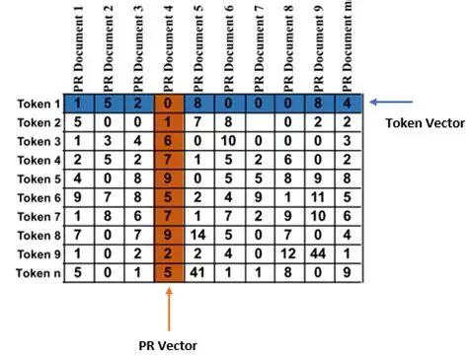
* Latent Dirichlet Allocation (LDA)
* Non-negative Matrix Factorization (NMF)

These methods represent documents as vocabularies and assume that each document is a mixture of different themes. They all start by converting a text corpus into a Document Term Matrix (DTM). A DTM is a table where each row/column is a document, and each column/row represents a unique word.

The entries in the matrix represent the frequency of each term in each document. Each cell contains count i and the number of times word j occurs in document i. A popular alternative to word count is the TF-IDF score which considers word frequencies in a bag of words.We consider term frequency (TF) and inverse document frequency (IDF) to penalize the weight of terms that frequently occur in the corpus and increase the weight of rare or irrelevant terms.

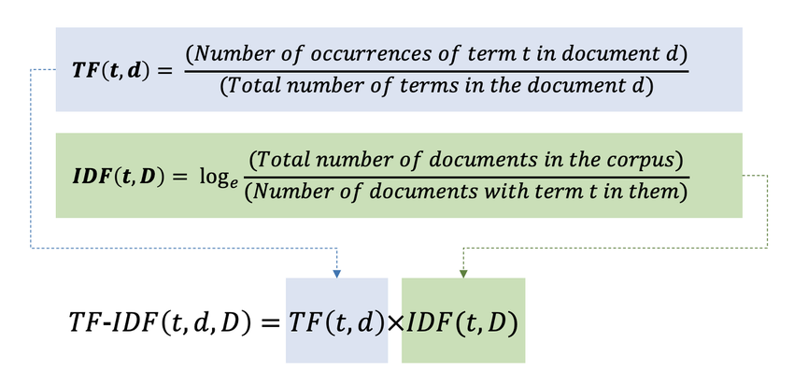

**TF-IDF Scores:** considers word frequencies in a bag of words.We consider term frequency (TF) and inverse document frequency (IDF) to penalize the weight of terms that frequently occur in the corpus and increase the weight of rare or irrelevant terms.

**Latent Semantic Analysis or Latent Semantic Indexing (LSA)**

* Idea is to take the matrix of things we have - "Documents and Concepts" - and break it down into separate Documents - Topic Matrix and Topic - Concept Matrix.
* LSA uses TF-IDF or term frequency-inverse document frequency to assign a weight to term j in document i as follows: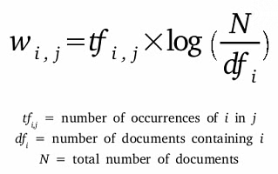
* Pros:
  + Fast and efficient
* Cons:
  + Lack of interpretable embeddings (we don't know what the subject is, and the components can be arbitrarily positive/negative)
  + Large amount of documentation required ( For robust performance, thousands of documents are preferred.)

**Latent Dirichlet Allocation (LDA)**

* From the Dirichlet distribution Dir(α), we draw a random sample representing the distribution of topics or a mixture of topics in a given document.
* ….

**Pachinko Allocation Model (PAM)**

* Pachinko's allocation model is improvised by establishing correlations between the generated themes. PAM emphasizes correlations between topics rather than between words, so it has a powerful ability to pinpoint semantic relationships.

Duplicates:

337-338

252-253

308-316

**Things to look out for LSA Finetuning**

* chunksize (int, optional) – Number of documents to be used in each training chunk.
* power_iters (int, optional) – Number of power iteration steps to be used. Increasing the number of power iterations improves accuracy, but lowers performance
* L4
  + Iterations/s = 3.00
  + Cost = 2.09 u/hr
* A100

Run Hyperparamter grid search on validation

Theron

| **Question** | To what extent does the RSPO conflict resolution machine offer an accessible, fair, and effective tool for communities in Indonesia to resolve conflicts with companies? |
| --- | --- |
| **Effectiveness** | CRM effectiveness depends on accessibility (Access to justice). This is the ability for people to make their grievances be heard and to maintain proper treatment for their grievances. |
| **Problems** | Biases often creep into rules guiding conflict resolution mechanism and the resolution strategy **|** Rural indonesians have difficulties with the complexity of the RSPO CRM feature due to them finding it intimidating and challenging to navigate **|** The tendency of the complaint panel to base its interim decision on the companies response, rather than a comprehensive investigation of the complaints allegations and responses objections, complaints, and process for villagers **|** RSPO struggles to deal with conflicts where there is a change of ownership **|** Companies can fail to provide requested information with no repercussions |
|  |  |

[**Text Representation Using Bag Of n-grams: NLP Tutorial For Beginners - S2 E5**](https://www.youtube.com/watch?v=nZromH6F7R0)

**N-Grams**

* Helps machines understand a word in its context to get a better understanding of the meaning of a word.
* The “N” in n-grams is just the number of words you want to look at
* The longer your context window the harder it is to pick up on words that frequently appear throughout the text when your looking at fairly unique sets of words
* ‘Goldilocks’ Approach(Recommended) not too long, not too short
* Looking at two pairs of words as the before word and after word is probably all the context you need to capture the meaning of the next
* Limitations: As n increased, dimensionality sparsity increases/ Doesn’t address out of vocabulary(OOV) problem

**Bi-Gram**

* Capturing a pair of words for context instead of individual words

🌴 Palm Oil Industry

Research on Palm Oil Industry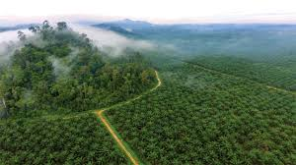

* Palm Oil: A vegetable oil derived from the mesocarp (red pulp) of the fruit of oil palms
  + Used in food manufacturing, beauty products and biofuel
  + Indonesia produces 60% of palm oil, followed by Malaysia, Thailand, and Nigeria
  + Crude red palm oil is refined, bleached, and deodorized (known as white palm oil)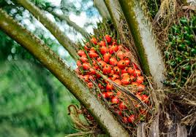
  + Popular in the commercial food industry due to its lower cost
  + Easier to stabilize
  + solid at room temperature often replaces butter in pastry and baked goods
  + Used as the foaming agent in nearly every soap, shampoo, and detergent
  + Around 70% of personal care products contain palm oil
  + Around ⅓ of all supermarket products contain palm oil
  + Industry is a significant contributor to deforestation in the tropics
  + Cause of social problems due to allegations of human rights violations among growers
  + Use of palm oil as biodiesel generates three times the carbon emissions as using fossil fuel

<https://en.wikipedia.org/wiki/Palm_oil>

| How is palm oil produced? <https://www.sustainablepalmoilchoice.eu/how-is-palm-oil-produced/#:~:text=The%20first%20stage%20of%20palm,from%20the%20water%20and%20solids>. |
| --- |
| Malaysia and Indonesia are leading producers of palm oil. Palm oil comes from oil palm trees grown on plantations, usually in tropical regions.  **PRODUCTION STAGES:**   * **Mill**, fresh palm bunches are received and processed  1. **Reception**, fruit is transported to the mill and undergoes inspections and quality assessment 2. **Sterilization**, high pressure steam deactivates enzymes and destroy bacteria 3. **Threshing**, thresher separates fruit from the bunch, resulting in a mixture of palm fruits and empty fruit bunches 4. **Extraction**, the fruits are processed for oil extraction. The fruit is pressed to extract crude palm oil from solid parts 5. **Clarification**, centrifuges and settling tanks remove impurities such as water and solids form the oil  * **Refinery**, further purification and enhancement  1. **Degumming**, crude palm oil is heated and mixed with water to remove gum and impurities, helps oil stability and appearance 2. **Neutralization**, oil is treated with alkaline substance (sodium hydroxide), which neutralizes any free fatty acids, this helps the oils suitability for its many applications 3. **Bleaching**, adds bleaching earth or activated carbon to remove pigments , residual impurities, and odors 4. **Deodorization**, oil is heated under vacuum conditions and steam is passed through the space to remove odors  * **Fractionation**, modifying physical characteristics of the oil’’  1. **Cooling and crystallization**, refined oil is chilled till it solidifies and forms crystals. It is then separated into two components Olein and Stearin 2. **Seperation**, Olein and stearin both undergo further processing. “Olein, which is liquid at room temperature, is suitable for applications such as cooking oil, while stearin, a solid fraction, finds use in products like margarine, shortening, and confectionery.”   **Palm kernel oil** is a byproduct derived from the seeds of oil palms. “While palm oil is extracted from the fleshy fruit, palm kernel oil is obtained from the inner kernel of the oil palm fruit.” |

| Deforestation & Palm Oil (Uri on this)  <https://www.sustainablepalmoilchoice.eu/deforestation-palm-oil/> |
| --- |
| * Palm oil plantations have emerged as a significant driver of deforestation, particularly in **Southeast Asia.** * The process of establishing palm oil plantations typically involves clearing land by removing existing vegetation, including dense tropical forests. These forests, which are often rich in biodiversity and home to numerous plant and animal species, are irreplaceable natural habitats. * Palm oil plantations are responsible for **5% of tropical deforestation** and **2.3% of global deforestation** * **Deforestation in Indonesia** due to palm oil has been steadily **decreasing** since 2012 * **RSPO and its Certified Sustainable Palm Oil (CSPO)**   + A CSPO is a certification obtained through a certification process conducted by the RSPO that verifies compliance with sustainability criteria at every stage of the palm oil supply chain. These criteria include the prohibition of deforestation, protection of wildlife habitats, respect for land rights, and responsible use of resources * **Large scale deforestation down, small scale deforestation up**   + While deforestation from large scale plantations is declining, deforestation from small scale farmers is increasing. For more than 3 million small farmers worldwide, palm oil is an important income source. Increasing the socioeconomic benefits while stopping deforestation is key. |

| Why Sustainable Palm Oil?  <https://www.sustainablepalmoilchoice.eu/why-sustainable-palm-oil/> |
| --- |
| “Unsustainable agricultural production of various crops can exacerbate climate change, destroy ecosystems, and endanger wildlife. They can also cause conflicts over land ownership and erode workers’ rights.”  There is a discourse about whether the solution to unsustainable palm oil is banning plam oil products or choosing an supporting sustainable palm oil. There are many reasons why palm oil, when produced sustainably, is a gret choice.   * “Palm oil is an incredibly productive crop with yields topping any other vegetable oil. Research shows that when palm oil is produced sustainably, with zero deforestation, the plantations can be a positive element in the local agroecological system, even attracting wildlife. The environment, workers’ rights, and the land rights of local people are all protected and livelihoods improved.” * Sustainably Produced Palm Oil Helps to Protect the Environment, * <https://www.sustainablepalmoilchoice.eu/sustainably-produced-palm-oil-protects-the-environment/> * Sustainably Produced Palm Oil Creates Robust Livelihoods * <https://www.sustainablepalmoilchoice.eu/sustainably-produced-palm-oil-creates-robust-livelihoods/> * Sustainable Palm Oil Producers Implement Decent Living Wages * <https://www.sustainablepalmoilchoice.eu/sustainable-palm-oil-producers-implement-decent-living-wages/> * Buying Sustainable Palm Oil Drives Industry Transformation * <https://www.sustainablepalmoilchoice.eu/buying-sustainable-palm-oil-drives-industry-transformation/> |

| **The Roundtable on Sustainable Palm Oil and WWF’s role in it**  [**RSPO Complaints Procedure**](https://www.youtube.com/watch?v=6SX3bQ2kqC8) | **RSPO complaints procedure**  [**How can palm oil be more sustainable? The Roundtable on Sustainable Palm Oil and WWF's role in it**](https://www.youtube.com/watch?v=0Lev1mnonUM) |
| --- | --- |
| More than 20 million hectares of land are covered in palm trees **|** The palm trees are mainly in malaysia and indonesia but increasingly in parts of Africa and Latin America **|** In 2004 the WWF( World Wide Fund for Nature) brought in all the parties involved with palm oil extraction which resulted in the RSPO **|** RSPO is a growing non-profit with over 3000 members that work together to make palm oil more sustainable **|** All the members are responsible for about half the world's palm oil production **|** The board consist of 16 seats, 4 of which are held by NGO’s **|** One of the huge successes of the RSPO is the Principles and criteria of sustainable palm oil **|** This certification standard helps protect nature and people | Anyone who feels as though they have been in violation of the RSPO has the right to submit a complaint to RSPO | The RSPO complaints procedure is supposedly a fair, transparent and impartial process to address complaints against RSPO members **|** It deals with complaints airing from a breach of RSPO key documents **|** Complaints against RSPO members include: Land conflicts, Deforestation , No new planting on peat , Clearing of HSV areas and HCS forest, Human rights violations, Health and Labor related issues **|** A complaint can be sent through their website, email, or by post **|** Once the complaint is accepted, an independent Complaint Panel consisting of RSPO members is formed to investigate the allegations **|** If the respondent is found to be in breach of the RSPO standards, sanctions may be imposed **|** Either party may appeal the decision if dissatisfied |

Consequences of palm oil production

Ways of pollution: reduced biodiversity, increased carbon emissions, and polluted nearby water sources due to run-off from fertilizers, pesticides, and palm oil effluents (POME). **POME is the main source of environmental pollution from the palm oil mill industry.**

Practical implementation of proposed options to reduce the environmental impact:

There are 26 options tested in Indonesia and mainly Thailand. Some proposed options are practical in Malaysia and Indonesia, such as Mulching EFB, EFB composting plant, and EFB pellets production. Mulching EFB is widely implemented in Malaysia and Indonesia because large-scale plantations are prevalent there.[1] **However,** Mulching EFB may have negative side-effects on N2O, NOx, and nitrate emissions.

LSA, AI topic assumptions

LSA Output:

LSA With TF-IDF: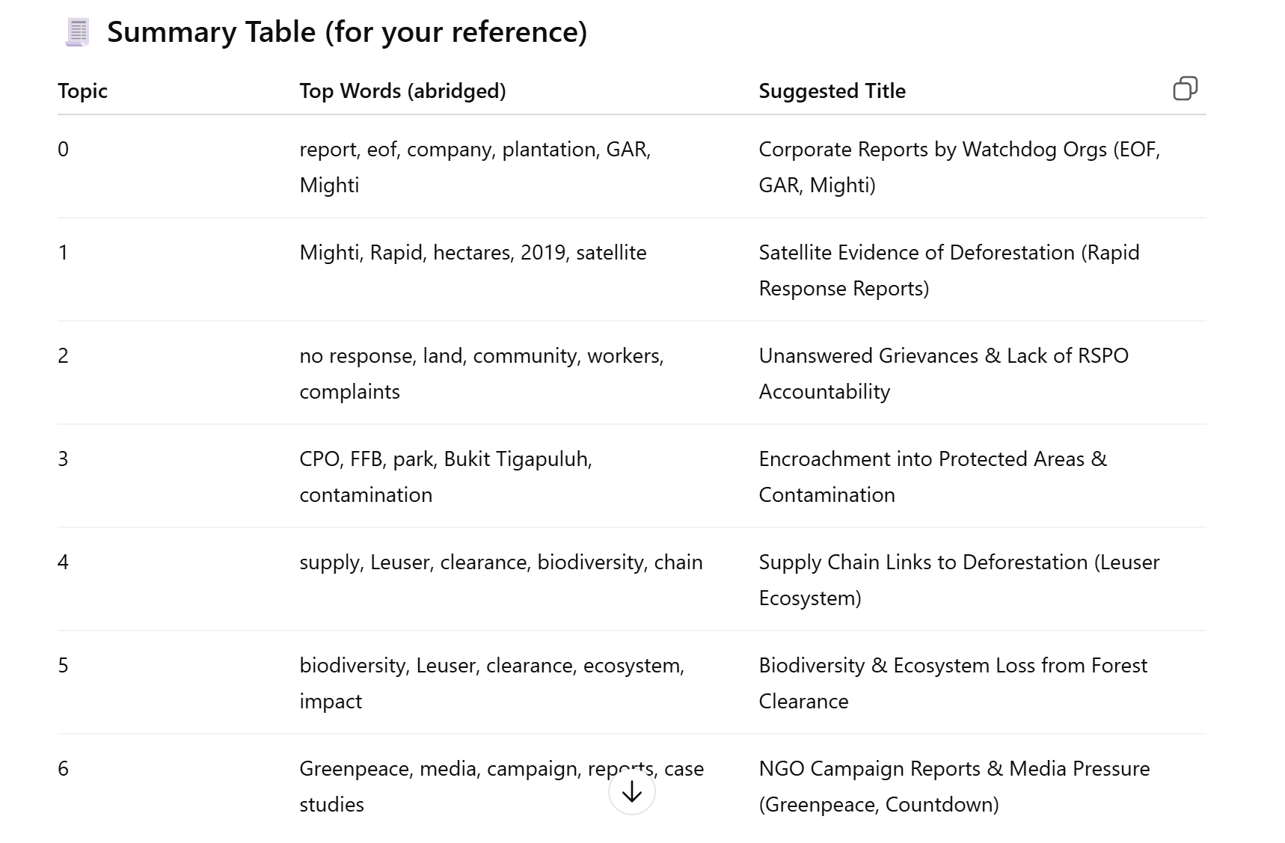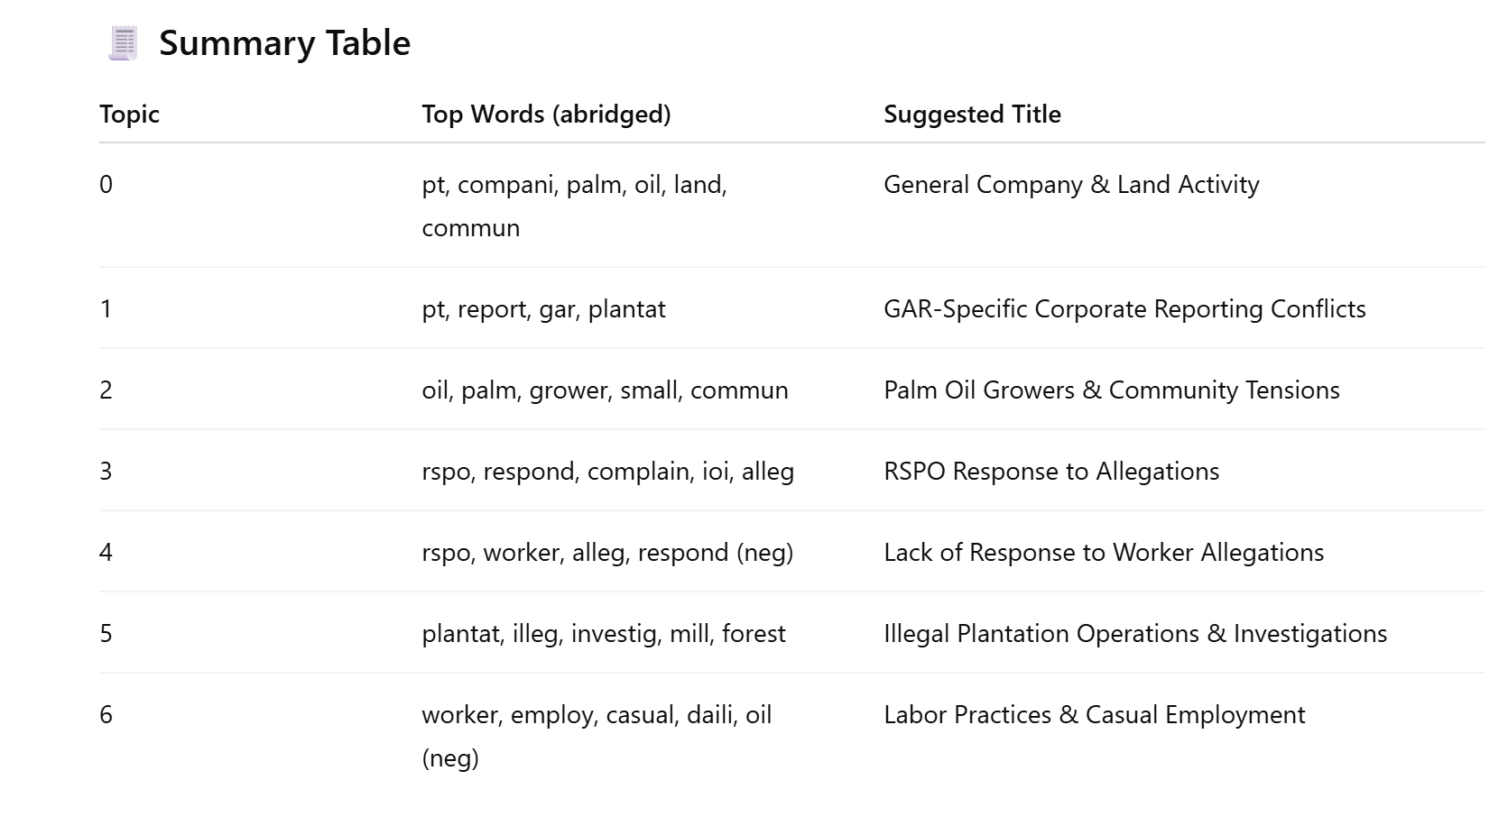

LDA Output: 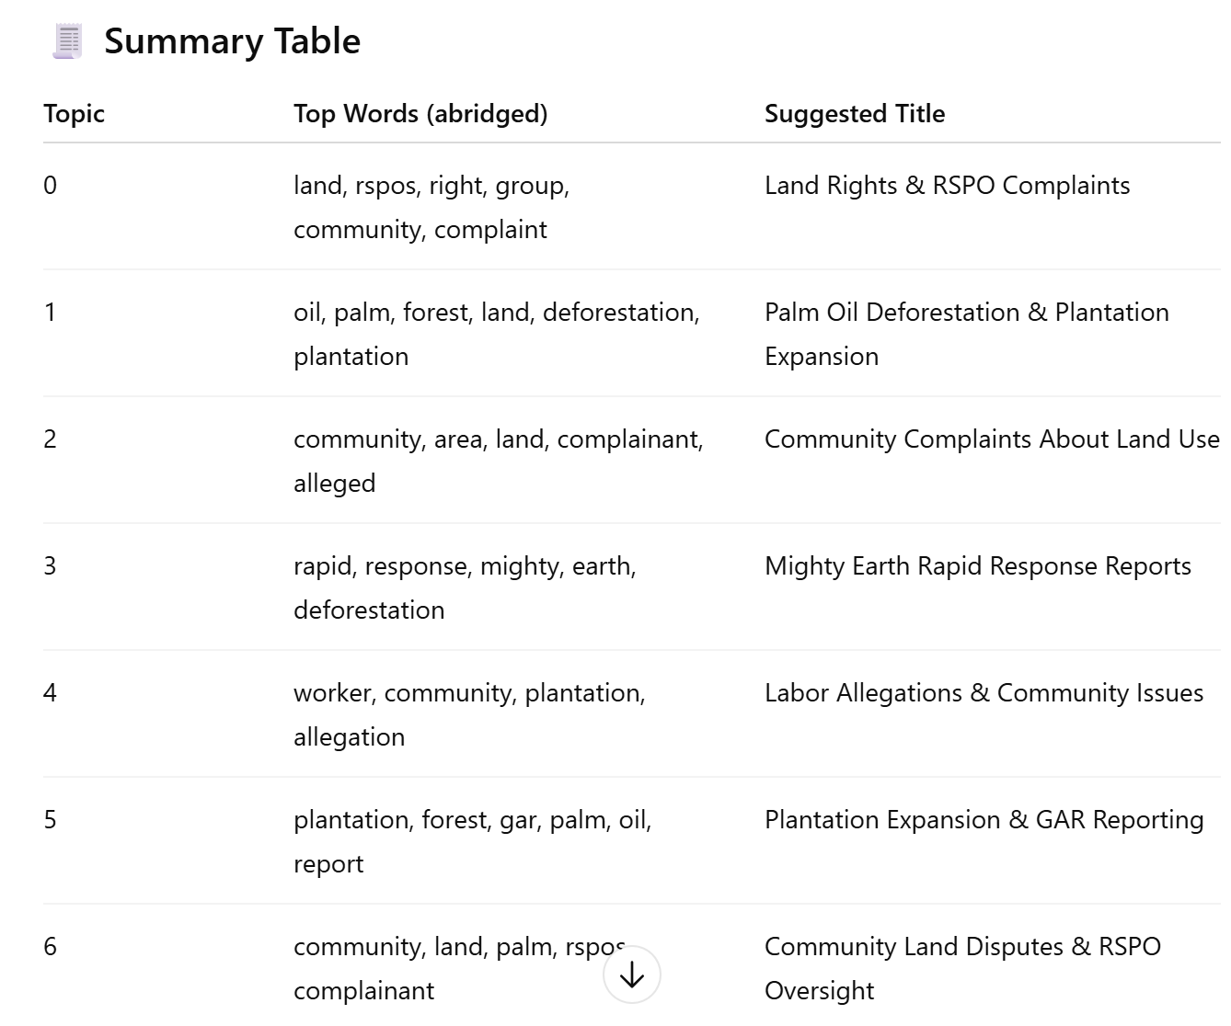

|  | ALL WORDS | YELLOW | ORANGE | RED |
| --- | --- | --- | --- | --- |
| LSA |  |  |  |  |
| LSA - TF IDF |  |  |  |  |
| pLSA | **(Topic names generated by copilot)**  **Topic 0: Deforestation & Reporting** deforestation (0.022), report (0.0216), indication (0.0203), response (0.0201), concession (0.0166), chain (0.0141), period (0.0140), agro (0.0138), group (0.0125), gar (0.0124)  **🧑‍🌾 Topic 1: Land Disputes & Community** respondent (0.0374), complainant (0.0289), land (0.0256), community (0.0213), area (0.0139), hcv (0.0114), forest (0.0104), acre (0.0104), assessment (0.0101), hectare (0.0088)  **👷 Topic 2: Labor & Employment** worker (0.0401), respondent (0.0219), union (0.0137), grower (0.0112), employment (0.0107), agreement (0.0086), holder (0.0084), payment (0.0082), electricity (0.0080), wage (0.0079)  **🏘️ Topic 3: Community Rights & Company Operations** community (0.0154), company (0.0145), area (0.0134), operation (0.0119), land (0.0118), right (0.0095), principle (0.0081), mediation (0.0075), violation (0.0073), rspo (0.0065)  **🏭 Topic 4: Investigations & Grievances** investigation (0.0202), plantation (0.0198), mill (0.0183), report (0.0176), eof (0.0155), bukit (0.0143), grievance (0.0142), company (0.0124), estate (0.0121), oil (0.0121)  **🏷️ Topic 5: Certification & Procedures** rspo (0.0260), oil (0.0137), procedure (0.0127), product (0.0124), certification (0.0117), group (0.0117), rspos (0.0100), fire (0.0099), complaint (0.0086), land (0.0080)  **🌿 Topic 6: Ecosystems & Allegations** leuser (0.0140), bumitama (0.0116), village (0.0095), allegation (0.0090), ecosystem (0.0088), ran (0.0084), complaint (0.0081), people (0.0080), biodiversity (0.0080), company (0.0079) |  |  |  |
| LLM |  |  |  |  |
| LDA |  |  |  |  |

Models at a Glance

Models:

LSA

P-LSA

LDA

NMF

LLM-BERTopic

* BERTopic is a topic modeling technique that leverages transformers and c-TF-IDF to create dense clusters allowing for easily interpretable topics. BERTopics uses embeddings generated by sentence transformer, which is a type of language model. So, while BERTopic is the overall topic modeling framework, it relies on a pre-trained language model to create the document embeddings.

LLM Model Clustering Onenote:

[DSSI Palm Oil Project](https://1drv.ms/o/c/faffac998f205d96/EqYEbVleoiBIv__bo8iNpNMBeqQaLdsXCKbzY_HWXX_aeQ?e=Rlxsvo)

🛠️ Finetuning

LSA

CHUNKSIZE - Number of documents to be used in each training chunk.

| **Size** | **Coherence Scores** |
| --- | --- |
| 387 (20000) | CV: 0.4313038040706992  UMASS: -5.094035325430307  CUCI: -6.984152566626299  CNPMI: -0.1588403779835468 |
| 60 | 0.436 |
| 50 | 0.408 |
| 40 | 0.444 |
| 30 | 0.397 |
| 20 | 0.434 |
| 10 | CV: 0.5638671852310725  UMASS: -5.435337241918609  CUCI: -5.099464576666672  CNPMI: -0.041727972643397004 |
| 7 | CV: 0.4824543606690866  UMASS: -4.812056896571909  CUCI: -6.25612505602364  CNPMI: -0.11719424109243978 |
| 5 | 0.472 |
| 1 | 0.440 |

POWER_ITERS - Technique used to estimate the dominant eigenvalue and its corresponding eigenvector of a matrix

| **Iterations** | **Coherence Scores** |
| --- | --- |
| 1 | CV: 0.37068071952451  UMASS: -6.650056285718031  CUCI: -4.956566376370406  CNPMI: -0.049912472213438606 |
| 2 (DEFAULT) | CV: 0.4313038040706992  UMASS: -5.094035325430307  CUCI: -6.984152566626299  CNPMI: -0.1588403779835468 |
| 3 | CV: 0.41840880659833496  UMASS: -4.56243903085356  CUCI: -7.06590714010963  CNPMI: -0.16662849016000883 |
| 4 | CV: 0.40364853159053277  UMASS: -6.018686369295204  CUCI: -4.350712084491554  CNPMI: -0.023231777296471943 |
| 10 | CV: 0.5208317517240444  UMASS: -4.3890456526055805  CUCI: -5.673624044714179  CNPMI: -0.0808615950600781 |
| 20 | CV: 0.40364853159053277  UMASS: -6.0195123935723975  CUCI: -4.350712084491554  CNPMI: -0.023231777296471943 |
| 100 | CV: 0.5483334207742823  UMASS: -3.069736450485728  CUCI: -3.64145213789568  CNPMI: 0.005167897166584942 |

**Parameters/Components Changed:**

* Tokenizers
* Power iteration count
* Training chunk size
* New Stopwords (Adding regions, company names
* Different Topic amount
* N-grams

**Result:**

* The model was able to classify simple topics like worker/labour rights and deforestation; other topics were either fully or semi-random.
* We would constantly encounter 2 huge “trash bin” topics, attempts at optimization failed to reduce these and in some cases made these topics even larger.
  + Out of 133 documents classified in one of these trash bins, 66 had the worker related topic as the second-most dominant. However, only ~15 out of those 66 were *actually* worker/labour related
* Duplicated summaries would cause the model to create a model just for duplicates, causing concern that it would only classify duplicates into it.

**Verdict on LSA (TF-IDF):**

* Despite being the best performing Latent Analysis model, due its lack of understanding context, it struggled to differentiate certain specific and/or verbose documents. This led to most topics being classified into 2 huge topics.

BERTopic

LLM/BERTopic Optimization

________________________________________________________

**Versions Tried:**

* Default (outliers removed)
* HDBScan
* K-Means with 6, 7, 8, 9, 10 topics
* Agglomerative Clustering with 6, 7, 8, 10 topics
* Uni-Bi-Gram Fuzzy C-means w/ 10 topics
* Fuzzy C-means w/ 6, 8, 10 topics
* Fuzzy with lemmatization 6 topics
* Fuzzy with UMAP 6 topics

**______________________________________________________________________________________________________**

**Trying to Improve Bert Model**

1. Tried multiple numbers of topics, settled on 6
2. Try different sentence transformer, giving us a giant topic like a trash topic
3. Try dimensionality reduction (UMAP), didn’t make a big difference but helped with reproducibility
4. Try lemmatization (horrible)
5. Tune BERTopic parameters
6. Use a Class-Based TF-IDF Representation:

* BERTopic uses c-TF-IDF to find topic words. You can improve this by filtering low-frequency words **before** modeling

1. Visual Inspection & Topic Reduction

* After training:

python

Copy code

bertopic_model.visualize_barchart(top_n_topics=15)   
bertopic_model.visualize_topics()

Use .reduce_topics(...) to combine overlapping topics:

python

Copy code

docs = df_embeddings["flt_tokens"].tolist()   
topics, probs bertopic_model.reduce_topics(docs, topics, nr_topics=10)

1. **Manually Inspect Top Documents**

* For each topic, view top representative documents:

python

Copy code

bertopic_model.get_representative_docs(topic=2)

If the top docs don’t clearly align with the topic keywords — either the model needs tuning or the data is noisy.

Twitter

| **PARAMETERS CHANGED** | **F1-SCORE (Micro)/ACCURACY** |
| --- | --- |
| Base | 0.52 |
| Batch_size = 4  Lr = 3e-5  Token_length = 128 | 0.55 |
| Batch_size = 4  Lr = 3e-5  Token_length = 256 | 0.30 |
| Batch_size = 8  Lr = 2e-5 | 0.55 |
| Batch_size = 8  Lr = 2e-5  Token_length = 128 | 0.36 |
| Lr = 1e-5 | 0.46 |
| Batch_size = 16  Lr = 1e-5  Token_length = 128 | 0.47 |
|  |  |

Implement Dropout

Print Report for Train

Parameter efficient finetuning

svdtrainer

Model Selection

Selection round 1

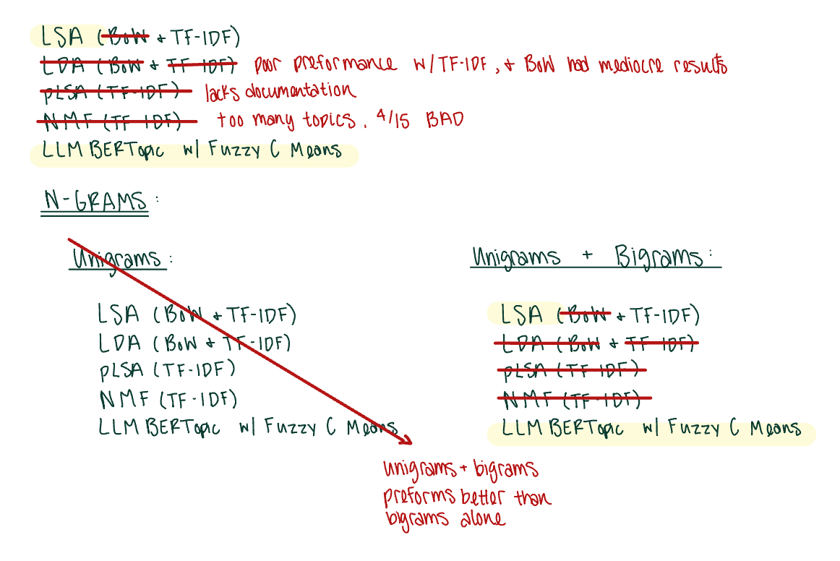

Selection round 2

| LSA | LLM BERTopic |
| --- | --- |
| Notes:  Pros:  Cons:  Explored: | Notes:  Pros:  Cons:  Explored: |
| Why NOT this model? | Why this model? |

Final model Finetuning:

LLM BERTopic

Transformer ranks

1. Rank 1. Twitter/twhin-bert-base: 4.8322 (Uriel)

* Good for informal/short text

1. Rank 2. SpanBERT/spanbert-base-cased: 4.7214 (Kamare)

* Good for understanding intra-sentence structure

1. Rank 3. Lianglab/PharmBERT-cased: 4.7145

* Strong generalization even though its biomedical

1. Rank 4. distilbert-base-cased: 4.7068 (Yuliia)

* Lightweight and competitive, usually the default for this problem

1. Rank 5. KISTI-AI/scideberta: 4.6760

* Turned for scientific language, might be overkill very strong

1. Rank 6. google/electra-base-discriminator: 4.6689
2. Rank 7. german-nlp-group/electra-base-german-uncased: 4.6513
3. Rank 8. FacebookAI/xlm-roberta-base: 4.6459
4. Rank 9. roberta-base: 4.6371
5. Rank 10. typeform/distilroberta-base-v2: 4.6315
6. Rank 11. microsoft/deberta-v3-base: 4.6242
7. Rank 12. dmis-lab/biobert-base-cased-v1.2: 4.6228
8. Rank 13. microsoft/mdeberta-v3-base: 4.5830
9. Rank 14. bert-base-cased: 4.5415
10. Rank 15. sentence-transformers/all-mpnet-base-v2: 4.4780
11. Rank 16. sentence-transformers/all-MiniLM-L12-v2: 4.0284
12. Rank 17. google/electra-small-discriminator: 3.9799

Could also try deepseek

1. <https://www.sciencedirect.com/science/article/pii/S0959652616308939#sec4.1>